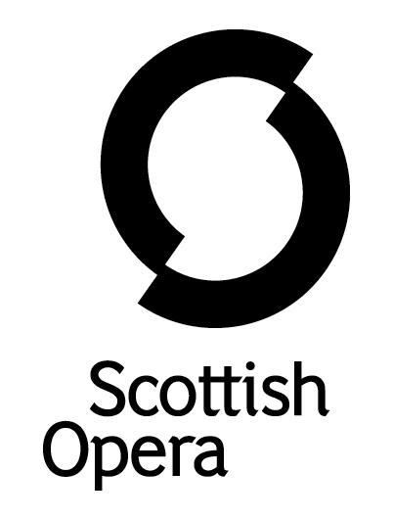
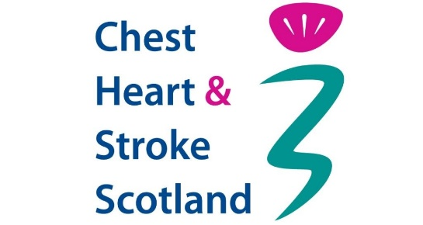

Press Release

20 June 2024

CHEST HEART & STROKE SCOTLAND AND SCOTTISH OPERA FORM NEW PARTNERSHIP TO BRING THE THERAPEUTIC BENEFITS OF SONG TO THOSE WITH APHASIA
- Building on Scottish Opera’s ground breaking Breath Cycle project, Chest Heart & Stroke Scotland is collaborating with the country’s largest performing arts organisation to improve the lives of those living with aphasia, a communication difficulty that is a common effect of strokes
- A new research report launched earlier this month by CHSS revealed that poor mental health and loneliness are severely impacting people in Scotland living with aphasia
Chest Heart & Stroke Scotland (CHSS) and Scottish Opera have joined forces to develop online singing classes for people living with aphasia, which is caused by damage to the part of the brain that controls language, and in some cases leaves some unable to speak at all.
These new CHSS and Scottish Opera sessions coincide with Aphasia Awareness Month, which runs throughout June. This year’s theme is #AphasiaTogether, emphasising that those with the condition do not need to deal with this on their own.
This new strand of creative music making with CHSS — Scotland’s largest health charity working to help people with chest, heart and stroke conditions live life to the full — expands upon Scottish Opera’s pioneering Breath Cycle project, designed to support those with a range of conditions affecting lung health.
Following research and development sessions with medical educators, CHSS staff and people living with aphasia are working with Scottish Opera to provide supported communication and aphasia training, and help deliver the therapeutic singing, song-writing and breath control sessions. The aim of these workshops is to improve the mental wellbeing and confidence in communication of those with aphasia and respiratory issues including COPD (Chronic obstructive pulmonary disease), across the country.
Earlier this month, CHSS launched a report about the impact of aphasia on those living with the condition which revealed that:

- More than half (52 per cent) of people with aphasia say their condition affects their mental health
- Nearly half (48 per cent) with aphasia said they experienced loneliness as a result of their condition.
- 43 per cent of people with aphasia said it impacted on their ability to work as before
- A third (34 per cent) of people with aphasia reported being treated negatively due to their condition

CEO of Chest Heart & Stroke Scotland, Jane-Claire Judson, commented: “Working with Scottish Opera to unlock the therapeutic benefits of singing and song-writing to people living with aphasia is a fantastic opportunity to tackle real issues facing people across the country.

“We regularly hear from the people we support that living with a communication difficulty following stroke can lead to feelings of isolation and loneliness and have a negative impact on mental health.

“We look forward to bringing people together to experience the joy of singing with others whilst exploring the benefits of singing and song writing to their communication skills.”

Jane Davidson MBE, Director of Outreach & Education at Scottish Opera said: “Following on from the increased awareness of our Breath Cycle II programme in 2020, which was designed for people living with Long COVID and other respiratory conditions, Scottish Opera is excited to partner with CHSS to support people with Aphasia.

“The work that CHSS undertakes each year with hundreds of thousands of Scots has set really high standards in the positive integration of mental health and well-being initiatives with clinical intervention. As Scotland’s largest performing arts company, we feel that the values of both our organisations are beautifully aligned in this new collaboration that seeks to enhance the quality of people’s lives across the country.”

Composer Gareth Williams, who along with writer Martin O’Connor, mentored the most recent online song writing Breath Cycle sessions said: “Our encounters with the Chest Heart & Stroke Scotland team, and our first conversations with our participants who have aphasia have been so inspiring. Our challenge is to help people find and connect with their voices again, both their physical voices and their creative voices. There are incredible stories to tell in this community, and together we will find them and share them through song.”

-Ends-
For additional press details please contact:
Emily Henderson, Scottish Opera Press Manager, 0141 242 0511
emily.henderson@scottishopera.org.uk
Emmy Borthwick, Senior Media Officer, Chest Heart & Stroke Scotland
0131 243 0164, emmy.borthwick@chss.org.uk

Notes to Editors

About Aphasia
Aphasia is a communication difficulty that affects 1 in 3 stroke survivors. Although it is most common after a stroke, it can occur with other neurological conditions and brain injury. It is estimated that there are over 40,000 people in Scotland living with the condition.
People with aphasia can have difficulty using words to express themselves, and sometimes have difficulty understanding words. Some people with aphasia also have difficulties in cognition or thinking.

Chest Heart & Stroke Scotland
Chest Heart and Stroke Scotland is Scotland’s largest health charity supporting people with chest, heart, and stroke conditions, including Long Covid, to live their lives to the full.
Its Community Healthcare Support Services are there for people at every stage of their condition.
CHSS provides a free advice line, organise peer support groups, offer health checks in local communities, and campaign to improve policies and services.
CHSS is Scotland’s largest volunteering organisation with over 4000 volunteers who help to deliver services, run 39 charity shops across Scotland, and raise vital funds to ensure people with our conditions can live life to the full.
To find out more about Chest, Heart & Stroke Scotland visit www.chss.org.uk

Breath Cycle
Breath Cycle was originally created in 2013 by Scottish Opera and Glasgow’s Gartnavel General Hospital Cystic Fibrosis Service to explore whether learning classical singing techniques, including breath control, can improve the wellbeing of patients. Scottish Opera repurposed the project during lockdown to offer support to people struggling with the debilitating effects of Long COVID. Since Autumn 2021, over 400 people from Scotland and across the world have been helping themselves to regain both their physical and mental health through a series of online training and mentoring Breath Cycle sessions with a group of Scottish Opera artists.

Scottish Opera
Scottish Opera is Scotland’s national opera company and the country’s largest performing arts organisation. The Company was founded in 1962 by Sir Alexander Gibson ‘to lay the treasures of opera at the feet of the people of Scotland’.
Scottish Opera’s repertoire ranges across five centuries, from the earliest operas to newly commissioned world premieres. For mainstage and concert productions, the Company collaborates with the world’s finest singers and creatives, The Orchestra of Scottish Opera, and choruses for each opera. Recent accolades include an International Opera Award 2023 nomination, South Bank Sky Arts Award, a Scottish Award for New Music, Sunday Herald Culture Awards, a 2017 UK Theatre Award, and a 2020 RPS Award. The 2023/24 Season sees productions first staged at Scottish Opera appearing in Paris, Cardiff, Detroit, Vancouver, and Toronto.
The Company tours extensively to ensure performances are within reach of as many of Scotland’s dispersed population as possible. Specially adapted Pop-up Opera performances bring shortened classics and original works to thousands of people each year. Opera Highlights presents arias and ensembles from across the repertoire in new narratives. This is one of the most extensive touring programmes of any European opera company and a much-valued contribution to Scotland’s cultural life, particularly in remote and island communities. In the 2022/23 60th Anniversary Season, performances were staged in over 60 locations across Scotland, and the same is achieved in 2023/24.
The Company’s Outreach & Education programme, the longest running in Europe, includes in-person and digital Primary Schools Tours, bringing children the opportunity to perform their own specially commissioned piece alongside professional singers. Around 120 schools and 9,000 pupils take part in the live tour each year. Scottish Opera aims to be inclusive and affordable through availability of free and subsidised tickets, audio-described performances, and specially devised Access performances with Dementia Friendly values at their core.
Scottish Opera is committed to presenting opera at the highest possible standards across Scotland as well as online to UK and worldwide digital audiences. The Company’s 2021 production of The Gondoliers, filmed live at Festival Theatre Edinburgh, is available on BBC iPlayer. Eight On Screen operas are available to watch at www. scottishopera.org.uk/what-s-on/opera-on-screen. These include Donizetti’s L’elisir d’amore, Mozart’s Così fan tutte, Menotti’s The Telephone, and Samuel Bordoli and Jenni Fagan’s The Narcissistic Fish.
Scottish Opera is core funded by The Scottish Government.

www.scottishopera.org.uk

