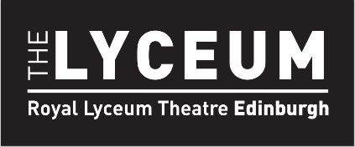
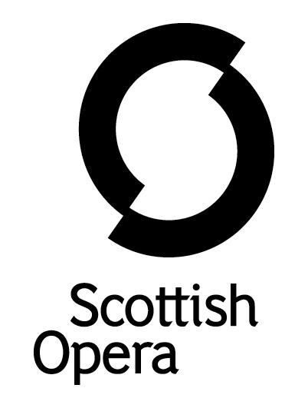

Press Release

21 December 2023

ROYAL LYCEUM THEATRE AND SCOTTISH OPERA PARTNER TO TRAIN PRODUCTION MANAGERS

Royal Lyceum Theatre Company and Scottish Opera are delighted to announce a new partnership project to rebuild skills in the Scottish Performing Arts sector by training and employing two Deputy Production Managers (DPM) for a period of two years, with the support of Sam Mendes’ Theatre Artist Fund’s Creative Workforce Pilot Programme.

A number of talented crafts people, technicians and production managers have moved out of the sector into Film, TV, streaming, and events during and after the COVID-19 pandemic. Both companies are keen to start to rebuild these skills in the sector, contributing to a healthy and sustainable arts economy in Scotland for the future.

Both The Lyceum and Scottish Opera have ambitious plans to increase their output at a range of scales – including mainstage, national and international touring, and smaller scale productions, as well as participatory / outreach activities. To support this increasing and diverse programme, it is important to actively encourage people to retrain or enhance their current experience and skills.

The focus on developing Production Managers has come about as the two companies have identified a long-term shortage of people with the experience and skill to work at a larger scale in both art forms as Production Managers. Up to now, there have been limited opportunities for local production managers to get experience in working in our larger theatres and particularly in opera. This programme will boost the pool of trained industry professionals in Scotland who can deliver the range and scale of Lyceum and Scottish Opera productions.

Each successful DPM candidate will spend up to 12 months with each organisation, but this may be divided over the two years according to project needs. This will enable each DPM to experience a wide range of scales of work, as well as cross-sectoral experience of working in both theatre and opera.
The Lyceum’s Executive Director, Mike Griffiths, said: ‘This welcome support from Sam Mendes’ Theatre Artist Fund is a major step in addressing the shortage of experienced Production Managers working in Scotland. We are very excited to be partnering with Scottish Opera on this ground-breaking initiative to offer the opportunity for mid-career opera and theatre practitioners to develop new skills and experience in production management at a larger scale.”

Scottish Opera’s Technical Director, Andrew Storer, said: ‘Following the tumultuous last few years, it is important to focus on the long-term health and sustainability of the live performance sector, which requires an investment in new talent now. I am immensely grateful to the Theatre Artist Fund for supporting the revitalisation of the sector and this training programme. I look forward to developing the capabilities of Production Management professionals to follow this hugely varied and exciting career path in live theatre. Scottish Opera has always been dedicated to emerging talent, as demonstrated by our long-running Emerging Artist programme, and this new collaboration allows us more resources to invest in the early careers of backstage professionals. The magic onstage is not possible without the skills of all behind the scenes.’

The Lyceum and Scottish Opera are looking for motivated and passionate individuals who will relish the opportunity to develop this vital role in our Production Teams. The role is not an entry level position and would suit somebody looking to move into a new mid-career role, either with previous Production Management experience at a smaller scale or with other technical or theatre craft experience – for example as a stage manager or theatre technician.

The DPMs will assist Scottish Opera’s Technical Director and the Lyceum’s Production Manager in coordinating the activity of the various technical teams working on new and revival main-scale productions, small-scale productions and on tour.

Interested prospective applicants can view the full job description, term details, and benefits
at https://lyceum.org.uk/jobs/deputy-production-manager or at https://www.scottishopera.org.uk/vacancies/deputy-production-manager/

The Creative Workforce Pilot Programme was announced in July 2021 by Sir Sam Mendes. Working in conjunction with Backstage Trust and Theatre Development Trust, the Theatre Artist Fund has designed a programme which will help to nurture and develop the creative workforce with new employment opportunities, in collaboration with performing arts venues across the UK. Starting in Autumn 2022 and culminating in Spring 2026, the pilot will realise twenty full-time jobs, each running for 2 years, for people working in craft and technical disciplines at emerging and mid-career level. Alongside economic stability, each person will be supported with integrated training as well as mentoring from established freelance theatre artists. The aim through this process is to identify new ways of working to help people develop their careers, encourage positive change for organisations, and benefit the wider creative industries and our communities.

-ENDS-
You can follow Scottish Opera on Facebook, Twitter, Instagram, You Tube and Tik-Tok @ScottishOpera www.scottishopera.org.uk
You can follow The Lyceum on Facebook, Twitter, Instagram @lyceumedinburgh
https://lyceum.org.ukNotes to Editors
The Royal Lyceum Theatre Company, Edinburgh is Scotland’s key producing theatre making work with and for a range of partners both in Scotland, UK and internationally. It makes up to seven new productions each year mainly for its 650 seat Victorian theatre, but also smaller productions including for the Edinburgh Fringe Festival. The company is also increasingly touring its work around Scotland, the UK and internationally. It has the largest Youth Theatre in Scotland and offers a range of other participation experiences for local participants. It works across three sites – the Theatre, an Administration and Rehearsal Block, and its scenery and costume workshops which are sited near Murrayfield Stadium. The Lyceum is supported by Creative Scotland and City of Edinburgh Council

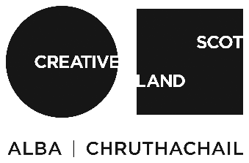

(https://lyceum.org.uk)

Scottish Opera is Scotland’s professional opera company which produces fully staged operas in Scotland and rents productions to opera companies across the globe. It is one of 5 National Performing Companies which are directly funded by the Scottish Government. It also has one of the most successful and longstanding engagement programmes. It is current based across 3 sites in Glasgow which comprise of Administration Offices/Rehearsal Rooms, a separate orchestra rehearsal room and the Productions Studios with Scenery, Costume and Props workshops. It currently produces 3 full operas each year, and rents many of its productions internationally as well as supporting a range of other projects including extensive tours of smaller productions to over 35 communities across Scotland. (https://www.scottishopera.org.uk)

Scottish Opera is supported by the Scottish Government.
For additional press details please contact: Emily Henderson, Press Manager, 0141 242 0511, emily.henderson@scottishopera.org.uk

