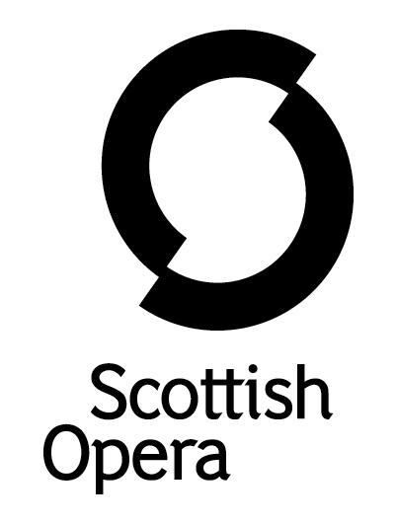

Press Release

06 December 2021

SCOTTISH OPERA PERFORMS DOUBLE BILL OF THE MISERLY KNIGHT AND MAVRA AT PERTH CONCERT HALL THIS MARCH

On Friday 18 March, Scottish Opera is coming to Perth Concert Hall for a double bill of short, striking Russian operas: the Scottish premiere of Sergei Rachmaninov’s The Miserly Knight and the Company premiere of Mavra, by Igor Stravinsky.

Adapted from stories by Russian poet, playwright, and novelist Alexander Pushkin, The Miserly Knight is a brooding story of a father and son destroyed by a hoarded treasure, whilst Mavra is a sharp-edged comedy about two lovers who go to inventive lengths to be together.

The Company’s Music Director, Stuart Stratford, conducts soloists including Alexey Dolgov (Silvano 2019), Alasdair Elliott (Pagliacci 2018), Alexey Gusev (Opera Highlights 2021), Anush Hovhannisyan (La traviata 2017), Alexander Krasnov, Sarah Pring (Jenůfa 2015) and 2021/22 Emerging Artist Lea Shaw (Opera Highlights 2021), in a concert staging by Laura Attridge. They are accompanied by over 60 musicians from The Orchestra of Scottish Opera.

Scottish Opera Music Director, Stuart Stratford said: ‘Rachmaninov’s music is ideally suited to the brooding and dark nature of The Miserly Knight. The extended harmonic language he uses is always trying to break free from its tonal roots in the same way that The Baron’s obsession with money is twisting his mind away from reason, and into a deranged state. We are thrilled that Alexander Krasnov will sing the role of The Baron, and to welcome back Alexey Dolgov and Alexey Gusev as the Prince and Duke respectively.

‘Mavra was regarded by Stravinsky himself as being one of his most important works. It stands on the border of his ‘Russian’ period and neoclassical writing, and has a terse economy of gesture and rhythmic propulsion which is added on top of his ‘wrong note’ harmony. This neoclassical style is crucial to the Pushkin short story and is highly effective at achieving the wit and pace of the text.’

James Waters, Creative Director for Classical Music at Perth Concert Hall, said: ’We couldn’t be more delighted to welcome Scottish Opera back for their second performance this season. Stuart Stratford’s performances of rare repertoire have been real eye-openers. Their choice this time of these two Russian Operas will intrigue and entertain in equal measure and we can’t wait.’

These performances are supported by Scottish Opera Endowment Trust and Friends of Scottish Opera. Tickets, priced £6-£36, are on sale now at www.scottishopera.org.uk/shows/the-miserly-knight-mavra/

You can follow Scottish Opera on Facebook, Twitter and Instagram @ScottishOpera

-ENDS-

Cast and creatives

Conductor Stuart Stratford
Director Laura Attridge

The Miserly Knight

Baron Alexander Krasnov
Albert Alexey Dolgov
Ivan/Servant John Molloy
Moneylender Alasdair Elliott
Duke/Gertzog Alexey Gusev

Mavra
Parasha Anush Hovhannisyan
The Hussar, Vassili (Mavra) Alexey Dolgov
Her Mother Sarah Pring
Neighbour Lea Shaw *

*Scottish Opera Emerging Artist 2021/22
Performance dates and venues
Friday 18 March, 7.30pm, Perth Concert Hall
Notes to Editors

All productions are created and performed in line with Scottish Government guidelines.
The Company’s Opera on Screen productions are available to watch at: www.scottishopera.org.uk/what-s-on/opera-on-screen/.
The collection includes Donizetti’s L’elisir d’amore, Humperdinck’s Hansel and Gretel, Mozart’s Così fan tutte, Opera Highlights, Janáček’s The Diary of One Who Disappeared, Menotti’s The Telephone and Samuel Bordoli and Jenni Fagan’s The Narcissistic Fish.
Scottish Opera is Scotland’s national opera company and the largest performing arts organisation in Scotland.
The Company's performance repertoire ranges across five centuries, from the earliest operas to newly-commissioned world premieres, working in collaboration with the world's finest singers and creatives, alongside The Orchestra of Scottish Opera and choruses. Recent accolades include a South Bank Sky Arts Award, a Scottish Award for New Music, Sunday Herald Culture Awards and a Herald Angel, as well as a 2020 RPS Award. In 2021 the Company returned to live audiences with Sir David McVicar’s new production of Verdi’s Falstaff performed in Glasgow and at Edinburgh International Festival.
The Company tours extensively across Scotland, from the largest-scale theatres to the smallest of rural venues, to ensure we are within reach of as many of our country's very dispersed population as possible. Our specially-adapted 40-foot long trailer brings ‘Pop-up Opera’ performances to thousands of people each year in a range of inspiring and unexpected community locations. In the Summer of 2021 the Company performed over 200 shows of its Pop-up Opera Roadshow, to socially distanced audiences of over 8000. This represents the most extensive touring programme of any opera company in Europe and is a much-valued contribution to Scotland’s cultural and artistic life, particularly in remote and island communities.
The Company’s Education and Outreach programme, which celebrates 50 years in 2021, includes an annual Primary Schools Tour, bringing upper primary-aged children the opportunity to perform their own specially-commissioned piece, alongside three professional singers. Around 120 schools and 9,000 pupils take part each year.
Scottish Opera aims to be inclusive and affordable through availability of free and cheap tickets, as well as performances offering audio description, and specially-devised shorter access performances.
Scottish Opera is core funded by The Scottish Government
For additional press details please contact:
Emily Henderson, Press Manager, 0141 242 0511,emily.henderson@scottishopera.org.uk
Julie McLaughlin, Press Officer, 0141 242 0552, julie.mclaughlin@scottishopera.org.uk

