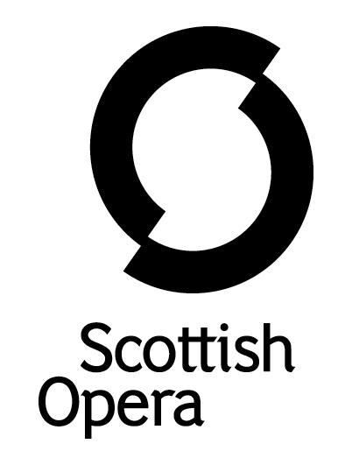

Press Release

21 January 2021

SCOTTISH OPERA Presents a filmed performance of humperdinck’s hansel AND GRETEL THIS FEBRUARY

Scottish Opera premieres Humperdinck’s enchanting Hansel and Gretel in the latest Scottish Opera: On Screen, filmed at Glasgow’s Theatre Royal on 19 December. The whole family can immerse themselves in this modern adaptation of the classic fairy tale from Wednesday 10 February at 6pm, via the Scottish Opera website. Before then, BBC Radio Scotland will feature audio excerpts from the performance as part of Classics Unwrapped, presented by Jamie MacDougall, on 7 February.

Sung in English, with staging by Daisy Evans, this vivid and joyful reimagining of Humperdinck’s opera tells the heart-warming story of two children and their journey from an impoverished home, into the mystery and danger of the woods. Brought to life by Daisy’s unique staging, with a Christmas-crazed witch and a shopping trolley full of sugary sweets and garish goodies, Hansel and Gretel seem a long way from their simple family life. Packed full of charm and sparkle this production is an ideal anytime treat for children and adults alike, sure to lift spirits and transport audiences from behind the screen to a world of hope and wonder. Although Hansel and Gretel is an opera traditionally associated with Christmas, Daisy's new production celebrates the opera's joy and hope that are just as powerful and relevant whatever the season.

David Parry conducts a cast including Kathleen Ferrier Award-winner Kitty Whately as Hansel, Rhian Lois (La bohème 2020) as Gretel, ENO Harewood Artist Nadine Benjamin as Mother and The Witch, Phillip Rhodes as Father and former Scottish Opera Emerging Artist Charlie Drummond (Così fan tutte, 2020) as The Sandman and The Dew Fairy, in a translation by David Pountney and with a reduced orchestration by Derek Clark. Humperdinck's chorus of gingerbread children is performed by a chorus of four adults.

Daisy Evans said: ‘This show is fun for all the family, bright colours, big energy and plenty of glitter! With the current pandemic, everybody has had a difficult Christmas, so I wanted it to be about finding joy where we can, and about families celebrating together. And I also want it to encourage people to come back to the theatre, and to bring their children with them – to make them want to be part of this experience, and to invest in it as part of our culture.’

Scottish Opera’s Head of Music, Derek Clark said: ‘Despite a prolific composing career, Humperdinck's reputation rests solely on this one opera. The combination of a straightforward fairy tale with a musical language which owes a heavy debt to Wagner may seem an unlikely one, but in Hansel and Gretel, the mixture of simple tunes, like the famous Dance duet, thrilling orchestral passages such as the Witch's Ride and the Dream pantomime, and the tender emotion of the children's Evening Prayer produces a masterpiece which has kept its popularity for well over a century.’

Available to watch via Scottish Opera’s website www.scottishopera.org.uk. Scottish Opera has also produced an Audio Described version of the film, also available to watch via the Company’s website. This is the latest in Scottish Opera’s Audio Described opera films, all of which have proved extremely popular with viewers.

Find out more about Daisy Evans staging of Humperdinck’s fairy tale opera in an exclusive interview: www.scottishopera.org.uk/news/an-exclusive-interview-with-daisy-evans-staging-hansel-gretel/

Ends.

Release Date, 10 February
Running time approx. 1 hour 40 minutes
Sung in English

Cast List
Hansel Kitty Whately
Gretel Rhian Lois
Mother and The Witch Nadine Benjamin
Father Phillip Rhodes
The Sandman and The Dew Fairy Charlie Drummond

Chorus
Barbara Cole Walton
Clíona Cassidy

Sarah Shorter
Jane Monari

Creatives
Staging Daisy Evans
Conductor David Parry
Orchestral Reduction Derek Clark

The Company’s Opera on Screen productions are available to watch at www.scottishopera.org.uk/what-s-on/opera-on-screen/.
The collection includes, Mozart’s Così fan tutte, Opera Highlights, Janáček’s The Diary of One Who Disappeared, Menotti’s The Telephone and Samuel Bordoli and Jenni Fagan’s The Narcissistic Fish.

Notes to Editors

Scottish Opera is Scotland’s national opera company and the largest performing arts organisation in Scotland. It was founded by Alexander Gibson in 1962 and was inaugurated with a production of Madama Butterfly at the King’s Theatre in Glasgow. In 1974 Scottish Opera purchased the Theatre Royal Glasgow, which reopened in 1975 as Scotland’s first national opera house. The Orchestra of Scottish Opera was founded in 1980.

Notable achievements include the world premiere of James MacMillan’s Inés de Castro at the 1996 Edinburgh International Festival; complete Ring cycles at the 2003 Edinburgh International Festival, which won the 2004 South Bank Show Award for Best Opera Production; and the Achievement in Opera Award at the 2017 UK Theatre Awards for Sir David McVicar’s production of Debussy’s Pelléas and Mélisande; and a Herald Angel for the European premiere of Missy Mazzoli's Breaking the Waves at the 2019 Edinburgh International Festival. The 2020 production of Nixon in China was nominated at the 2020 Royal Philharmonic Society award.

Commissions include Five:15 Operas Made in Scotland (2008–10), The Lady from the Sea, Clemency, the double bill of In the Locked Room and Ghost Patrol (premiered at the 2012 Edinburgh International Festival), 2016’s The Devil Inside, with which Scottish Opera made its North American debut in Toronto, and 2019’s Anthropocene. Ghost Patrol won a South Bank Sky Arts Award, and In the Locked Room and Ghost Patrol were nominated for an Olivier Award. In 2018 the company made its US debut with BambinO at the Metropolitan Opera in New York, and returned later that year to the city’s Brooklyn Academy of Music with Mark-Anthony Turnage’s Greek.

Scottish Opera is committed to bringing the widest possible range of opera, performed to the highest possible standards, to the maximum audience throughout Scotland and the UK. Each year it performs in Glasgow, Edinburgh, Aberdeen and Inverness and dozens of other theatres, village halls and community centres. It also operates an extensive programme of outreach and education work which involves over 9,000 primary school children every year, as well as many other activities including adult learning and Unwrapped taster sessions. Scottish Opera receives core funding from the Scottish Government, as well as income from box office, and private and commercial support.

For additional press details please contact:
Julie McLaughlin, Press Officer, 0141 242 0552, julie.mclaughlin@scottishopera.org.uk

