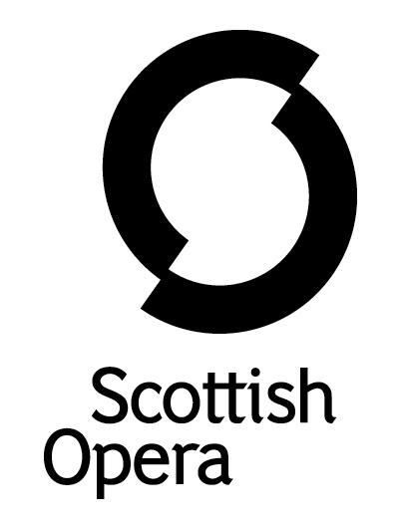

Press Release

13 October 2020

SCOTTISH OPERA PRESENTS AN ONLINE PRODUCTION OF OPERA HIGHLIGHTS

Scottish Opera presents a digital version of its hugely popular Opera Highlights, which will be released on October 25, World Opera Day, at 6pm.

While the Autumn tour usually sees the company travelling the highways and byways to many different venues in far reaching Scottish communities, this year’s online Opera Highlights is a celebration of opera, music and performance in the time of social distancing. This digital production, filmed in the theatre of The Beacon Arts Centre, Greenock, will be available to audiences across Scotland and beyond via Scottish Opera’s website.

Director Rosie Purdie’s colourful production of Opera Highlights looks at the current challenges facing performers in the time of Covid-19 and the strange new practises required in life and on stage. The production imagines a time when performance can once again happen inside theatres, with four singers delighted to be performing live for the first time since lockdown, even if it means embracing the 3 metre social distancing required at this time. A determined organiser struggling to make sure everyone follows the rules, a disorganised singer and social distancing getting in the way of flourishing romances, make for a fun and relevant production of this year’s Opera Highlights.

Scottish Opera’s Head of Music Derek Clark has curated a playlist of operatic classics and must-hear rarities, with highlights including Verdi’s Brindisi, Bizet’s Habanera and more from the likes of Gilbert and Sullivan, Mozart and Lehár.

Pianist Susannah Wapshott is joined by Scottish Opera Emerging Artists soprano, Catriona Hewitson, mezzo-soprano Margo Arsane, tenor Shengzhi Ren and baritone Arthur Bruce.

As well as the production being available online, audiences will be able to delve further into Opera Highlights with the digital programme, which will also be available on the Scottish Opera website.

The Company hopes to tour Opera Highlights to venues across Scotland as soon as they are able to re-open to audiences, in line with Scottish Government guidelines.

Opera Highlights Director Rosie Purdie said: ‘At this time I wanted this production of Opera Highlights to feel bright and merry, provide a few much-needed laughs, and exhibit some wonderful music. Four different singers come together to sing on the stage for the first time in many months. The cast and everyone backstage have worked extremely hard against the odds, embracing the restrictions and the distancing to create a colourful show designed to make you smile.’

Scottish Opera’s General Director, Alex Reedijk, said: ‘While this year’s production is taking a different form to our usual tour, I am delighted that we are able to continue our much acclaimed productions of Opera Highlights in these times, through this film. We look forward to a time when we take this tour to venues right across Scotland, hopefully soon, and that in the meantime this film will be a welcome diversion.’

This production of Opera Highlights is supported by The Friends of Scottish Opera,
JTH Charitable Trust and The Scottish Opera Endowment Trust.

-ENDS-

www.scottishopera.org.uk

You can follow Scottish Opera on Facebook, Twitter and Instagram @ScottishOpera

Opera Highlights Autumn Tour Cast and Creative Team

Soprano Catriona Hewitson*
Mezzo-soprano Margo Arsane*
Tenor Shengzhi Ren*
Baritone Arthur Bruce**
Pianist Susannah Wapshott

Director and Script Writer Rosie Purdie
Music Directors Jonathon Swinard and Susannah Wapshott
Programme Derek Clark
Director of Film Production Antonia Bain
*Scottish Opera Emerging Artist
**The Robertson Trust Scottish Opera Emerging Artist

Notes to Editors

Scottish Opera is Scotland’s national opera company and the largest performing arts organisation in Scotland. It was founded by Alexander Gibson in 1962 and was inaugurated with a production of Madama Butterfly at the King's Theatre in Glasgow.
Notable achievements include the world premiere of James MacMillan's Inés de Castro at the 1996 Edinburgh International Festival; complete Ring cycles at the 2003 Edinburgh International Festival, which won the 2004 South Bank Show Award for Best Opera Production; and the Achievement in Opera Award at the 2017 UK Theatre Awards for Sir David McVicar’s production of Debussy’s Pelléas and Mélisande. Recent commissions include Five:15 Operas Made in Scotland (2008-10); The Lady from the Sea, Clemency, the double bill of In the Locked Room and Ghost Patrol (winner of a South Bank Sky Arts Award) which premiered at the 2012 Edinburgh International Festival and 2016's The Devil Inside by Stuart MacRae and Louise Welsh. Earlier this year the Company made its US debut with BambinO at the Metropolitan Opera New York, and returns to the city’s Brooklyn Academy of Music with Greek in December.
Scottish Opera is committed to bringing the widest possible range of opera, performed to the highest possible standards, to the maximum audience throughout Scotland and the UK. Each year it performs in Glasgow, Edinburgh, Aberdeen and Inverness, as well as smaller theatres, village halls and community centres throughout the country.
Scottish Opera’s Education and Outreach Department was the first of its kind of any opera company in Europe. It operates an extensive programme which involves over 8,000 primary school children every year as well as many other activities including adult learning and Unwrapped taster sessions.
Scottish Opera is supported by the Scottish Government.

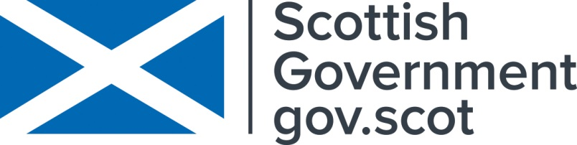

For additional press details please contact:
Julie McLaughlin, Press Officer, 07825981241, julie.mclaughlin@scottishopera.org.uk

.

