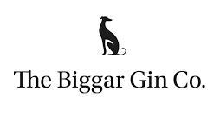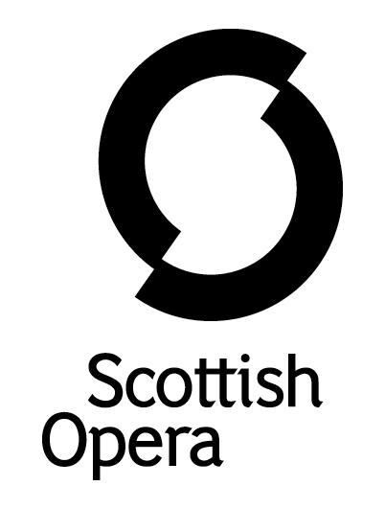

Press Release

27 October 2022

SCOTTISH OPERA LAUNCHES NEW GIN CALLED SUONARE IN PARTNERSHIP WITH THE BIGGAR GIN COMPANY TO MARK 60TH ANNIVERSARY
Scottish Opera marks its 60th Anniversary by partnering with The Biggar Gin Company to create a new artisan gin called Suonare. Translating ‘to play’, Suonare is a bespoke gin using botanicals inspired by operas in the Company’s 60th Season, in a celebration of artisan craftsmanship and mixology.
Available to order from today, this gin features a red label with die-cut holes which when removed and placed in a music box plays ‘Un bel di’ from Puccini’s Madama Butterfly. Performed in Scottish Opera's very first Season in 1962, this was a favourite of the Company's founder, Sir Alexander Gibson. Combining gin with this unique music box element makes this an ideal Christmas gift.
Suonare is a London Dry style gin with botanicals chosen from areas that have a strong connection with the operatic world, with oranges from Seville, lavender from France, bergamot from Calabria in Italy, pink peppercorn from South America and adding in the important Scottish connection with nettles from the Borders. The flavours also reflect the international repertoire of Scottish Opera’s 60th Season including Bizet’s Carmen (Spain), Osvaldo Golijov’s Ainadamar (South America), Puccini’s Il trittico and The Verdi Collection (Italy), Bernstein’s Candide and Massenet’s Thérèse (France). The die-cut holes on the label then correspond to the 14 botanicals used in the gin and are listed by the ability to taste the high and low notes of each by matching them with their musical equivalent in the Madama Butterfly aria. Blind tastings were held with Scottish Opera supporters to help refine the flavour of the gin.
Alex Reedijk, Scottish Opera General Director: ‘We wanted to create something celebratory that our patrons could share in and enjoy, to mark this significant milestone in our history. The choice of a gin was made as a way of creating something that would be representative of our respect for tradition and excitement around innovation, craftsmanship and artistry. We also wanted to partner with a local artisan business which would reflect the heart of our philosophy to tour to communities and bring opera to doorsteps across Scotland. Our search for a distiller with these qualities led us to The Biggar Gin Company, who are equally committed to creating something special. The inclusion of our first ever production Madama Butterfly in the design, along with the flavours representing our 60th Season, is a way of celebrating not only our history but where we are today. We hope that people feel this is a way of joining in our year of festivities either by raising a glass or saving this unique bottle as a memento of our Diamond anniversary – or both!’
Stuart McVicar, The Biggar Gin Company co-founder said: ‘We were excited to be approached by Scottish Opera to help create a blend that they felt would best celebrate their impressive 60-year history. When we visited the Company’s production studios, we could see the passion and precision in the artisan skills that go in to the creation of each performance and wanted to ensure we could make a product which would reflect this mix of tradition and innovation. We started off supplying the team at Scottish Opera with a number of different sample gins, connecting botanicals with locations significant to opera. After a number of tasting sessions, we tied this down. As for the gin itself, it could be described as a classic and traditional London Dry Gin which then incorporates citrus-led notes of high limes, orange and lemon, plus Italian bergamot and a gentle element of spice.’
Award winning Glasgow-based creative design agency, Tangent, conceived the concept and designed the Suonare bottle using sustainably sourced materials from Britain. Using FSC approved cardboard for the label, the cap has also been hand-dipped in gold wax to seal the product and avoid using plastics.
The launch of the gin forms part of a year of celebrations for Scottish Opera’s 60th Anniversary. The Company also marks the occasion by committing to bring opera to over 60 communities across all points of the compass around Scotland this Season. 2023 will also see an exhibition held in Theatre Royal Glasgow celebrating the work of the Company’s 60-year history.
Suonare is available to buy from The Biggar Gin Company’s website for £38 www.biggargin.com/shop
-ENDS-
You can follow Scottish Opera on Facebook, Twitter and Instagram @ScottishOpera
www.scottishopera.org.uk
Notes to Editors
Scottish Opera is Scotland’s national opera company and the largest performing arts organisation in Scotland. The Company was founded in 1962 by Sir Alexander Gibson with the goal ‘to lay the treasures of opera at the feet of the people of Scotland’, opening with performances of Madama Butterfly and Pelléas et Mélisande. The 2022/23 season marks its 60th Anniversary.
Scottish Opera’s performance repertoire ranges across five centuries, from the earliest operas to newly-commissioned world premieres, balancing favourites with under-explored works. The Company collaborates with the world’s finest singers and creatives, together with The Orchestra of Scottish Opera and choruses for each opera. Recent accolades include a South Bank Sky Arts Award, a Scottish Award for New Music, Sunday Herald Culture Awards, a 2017 UK Theatre Award, and a 2020 RPS Award. The Company took operas to Brooklyn in 2017 and Adelaide in 2020, and the 2022/23 season sees productions first staged at Scottish Opera appearing in Santa Fe, Madrid, Toulouse, and Los Angeles. The 60th Anniversary Season includes the UK fully-staged premiere of Osvaldo Golijov’s Ainadamar and the Company premiere of Puccini’s Il trittico.
The Company tours extensively across Scotland to ensure performances are within reach of as many of the country’s dispersed population as possible – this year, 60 locations across the length and breadth of the country. Specially-adapted 40-foot long trailers bring Pop-up Opera performances to thousands of people each year. This is one of the most extensive touring programmes of any European opera company and a much-valued contribution to Scotland’s cultural and artistic life, particularly in remote and island communities.
The Company’s Education & Outreach programme, the oldest in Europe, includes an annual in-person and digital Primary Schools Tour, bringing children the opportunity to perform their own specially-commissioned piece alongside professional singers. Around 120 schools and 9,000 pupils take part each year. Scottish Opera aims to be inclusive and affordable through availability of free and cheap tickets, as well as performances offering audio description and specially-devised shorter access performances.
Scottish Opera is committed to making opera for all, presenting opera at the highest possible standards in theatres across the country, outdoors on tour, and digital audiences around the world. The Company’s 2021 production of The Gondoliers, filmed live at Festival Theatre Edinburgh, is available on BBC iPlayer. Scottish Opera’s On Screen productions are available to watch at www.scottishopera.org.uk/what-s-on/opera-on-screen. The collection includes Donizetti’s L’elisir d’amore, Humperdinck’s Hansel and Gretel, Mozart’s Così fan tutte, Opera Highlights, Menotti’s The Telephone, and Samuel Bordoli and Jenni Fagan’s The Narcissistic Fish. A new commission will be announced in 2023.
The Biggar Gin Company
Biggar as a place has a reputation for innovation and punching above its weight, and The Biggar Gin Co. is no exception. The Bigger Gin Co. was established by brothers Stuart and Euan McVicar in 2018. The brothers work from their distillery at the bottom of Tinto Hill in South Lanarkshire and their gin is based on a philosophy. The philosophy centres on a ‘Biggar Mentality’. Small batch, quality crafted gins that mix tradition and innovation. Combining modern distilling methods whilst refining processes and adapting new methods to make unique gin. Gin that is made with passion, care and a focus on taste that reflects the local landscape but also pays homage to traditional gin.
For additional press details please contact:
Emily Henderson, Press Manager, 0141 2420511,emily.henderson@scottishopera.org.uk
Julie McLaughlin, Press Officer, 0141 242 0552, julie.mclaughlin@scottishopera.org.uk

