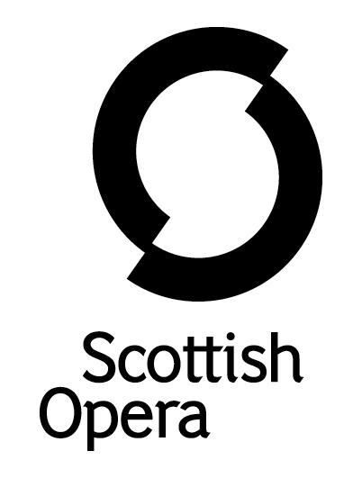

Press Release

29 June 2022

SCOTTISH OPERA’S FIVE-STAR ‘OPERA FOR BABIES’ BAMBINO TOURS TO EIGHT VENUES AROUND SCOTLAND THIS AUGUST AND SEPTEMBER

BambinO, Scottish Opera’s critically acclaimed ‘opera for babies’, is touring to East Kilbride, Perth, Inverness, Banchory, Aberdeen, Edinburgh, Motherwell and Renfrew between 13 August and 11 September.

Written by the Company’s former Composer in Residence Lliam Paterson, BambinO was originally directed by Improbable’s Phelim McDermott, and is revived by Lissa Lorenzo. The pioneering and unique piece of music theatre, which is sung in English, is ideal for infants up to 12 months. It celebrates the possibilities of music and the power of the infant imagination by reinventing operatic language and traditions for children at an age when their minds are wide open to new sounds, images and experiences. Babies are free to explore during the performance, and to interact with the singers and each other.

Designed by Emma Belli & Giuseppe Belli, BambinO is set in a captivating world of bright colours, fluffy clouds, and quirky characters, and tells the story of a young bird leaving its nest for the first time, with Charlotte Hoather and Samuel Pantcheff reviving the roles of Uccellina and Pulcino. They are accompanied by cellist Andrew Drummond Huggan and percussionist Darren Gallacher, and the Music Director is Chris Gray.
A co-production with Manchester International Festival and Improbable, BambinO premiered in 2017 and has since toured all over Scotland including to Glasgow and Edinburgh Festival Fringe as well to Théâtre du Châtelet in Paris, The Metropolitan Opera in New York and the Royal Opera House Muscat in Oman.

Scottish Opera’s Director of Education and Outreach, Jane Davidson, said: ‘We are delighted to be back touring this wonderful production after a four year hiatus. This is a magical piece of music theatre specially created for our littlest audience members, who often do not get a look-in at opera, but who greatly benefit from the power of music. It is a perfect opportunity to experience opera, created in miniature, through the eyes, ears and imagination of your very own bambinos, as they explore a beautifully crafted world full of golden eggs, soft blue cushions, fluffy clouds and soaring notes.’

BambinO is kindly supported by Scottish Opera’s New Commissions Circle and Scottish Opera’s Education Angels.

-ENDS-
www.scottishopera.org.uk
You can follow Scottish Opera on Facebook, Twitter and Instagram @ScottishOpera

Cast and Creative Team

Composer Lliam Paterson
Music Director Chris Gray
Original Director Phelim McDermott
Revival Director Lissa Lorenzo
Original Designers Giuseppe Belli & Emma Belli

Uccellina Charlotte Hoather
Pulcino Samuel Pantcheff
Cello Andrew Drummond Huggan
Percussion Darren Gallacher

Performance Diary

East Kilbride Arts Centre
Saturday 13 August & Sunday 14 August, 10am & 11.30am

Perth Theatre
Thursday 18 August, 10am & 11.30am
Friday 19 August, 10am

Eden Court Inverness
Saturday 20 & Sunday 21 August, 10am & 11.30am

The Barn, Banchory
Wednesday 24 and Thursday 25 August, 10am & 11.30am

Music Hall Aberdeen
Friday 26, Saturday 27 & Sunday 28 August, 10am & 11.30am

Festival Theatre, Edinburgh
Thursday 1, Friday 2, Saturday 3 and Sunday 4 September, 10am & 11.30am

Motherwell Concert Hall
Tuesday 6 September, 11.30am
Wednesday 7 September, 10am & 11.30am

Renfrew Town Hall
Saturday 10 & Sunday 11 September, 10am & 11.30am

Notes to Editors
Scottish Opera is Scotland’s national opera company and the largest performing arts organisation in Scotland. The 2022/23 season marks its 60th Anniversary.
The Company’s performance repertoire ranges across five centuries, from the earliest operas to newly-commissioned world premieres. Scottish Opera collaborates with the world’s finest singers and creatives, together with The Orchestra of Scottish Opera and choruses for each opera. Recent accolades include a South Bank Sky Arts Award, a Scottish Award for New Music, Sunday Herald Culture Awards, a Herald Angel, and a 2020 RPS Award. In 2021 the Company returned to live audiences with Sir David McVicar’s new production of Verdi’s Falstaff performed in Glasgow and at the Edinburgh International Festival.

The Company tours extensively across Scotland to ensure performances are within reach of as many of the country’s very dispersed population as possible. Specially-adapted 40-foot long trailers bring Pop-up Opera performances to thousands of people each year. In 2021 the Company performed nearly 200 performances of its Pop-up Opera Roadshow to socially distanced audiences of 11,014 people. This is one of the most extensive touring programmes of any European opera company and a much-valued contribution to Scotland’s cultural and artistic life, particularly in remote and island communities.

The Company’s Education & Outreach programme, which celebrated 50 years in 2021, includes an annual Primary Schools Tour, bringing children the opportunity to perform their own specially-commissioned piece alongside professional singers. Around 120 schools and 9,000 pupils take part each year. Scottish Opera aims to be inclusive and affordable through availability of free and cheap tickets, as well as performances offering audio description and specially-devised shorter access performances.

The Company’s Opera on Screen productions are available to watch at: www.scottishopera.org.uk/what-s-on/opera-on-screen. The collection includes Donizetti’s L’elisir d’amore, Humperdinck’s Hansel and Gretel, Mozart’s Così fan tutte, Opera Highlights, Menotti’s The Telephone, and Samuel Bordoli and Jenni Fagan’s The Narcissistic Fish. The Company’s 2021 production of The Gondoliers, filmed live at Festival Theatre Edinburgh, is available on BBC iPlayer.

For additional press details please contact:
Emily Henderson, Press Manager, 0141 242 0511, emily.henderson@scottishopera.org.uk
Julie McLaughlin, Press Officer, 0141 242 0552, julie.mclaughlint@scottishopera.org.uk

