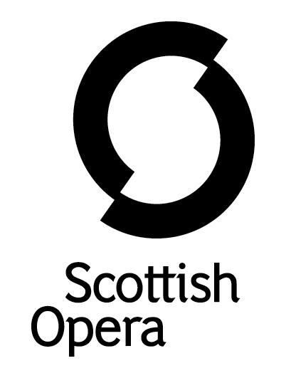

Press Release

21 January 2021

national opera studio RETURNS TO SCOTTISH OPERA for
ANARCHY AT THE OPERA in FEBRUARY

Scottish Opera is delighted to welcome 15 young performers from the National Opera Studio for a week long residency in Glasgow, culminating in a performance at Theatre Royal Glasgow on 25 February entitled Anarchy at the Opera.
In a partnership that spans 45 years, this is the first time since 2019 that the residency and performances have been able to take place in Glasgow because of the pandemic. The young performers, which comprises eleven singers and four pianists, will spend the week working with Scottish Opera music staff to rehearse their repertoire, before performing with The Orchestra of Scottish Opera conducted by Head of Music Derek Clark. The artists hail from all over the world including Ukraine, Latvia, South Africa, America, Korea as well as the UK.
The performance takes place on the set of Britten’s A Midsummer Night’s Dream which is currently in rehearsal at Scottish Opera. Audiences should look forward to a fun and energetic performance in a programme that includes works by Rossini, Handel, Poulenc, Shostakovich, Offenbach and more.

Director Emma Jenkins said: ‘This year, the young artists will explore the theme of ‘Absurdism’ through the medium of some of the most anarchic and off-the-wall pieces in the operatic repertoire. The event will be very much an ensemble effort testing their physical skills as well as their vocal prowess. From Les Mamelles des Tirésias to Alcina, from Cheryomushki to Le Roi Carotte, the audience can look forward to a thrilling evening of anarchy and mirth.’

Scottish Opera General Director, Alex Reedijk, said: ‘Our long term partnership with National Opera Studio is one that we continue to cherish and have missed over the last few years due to the pandemic. We can’t wait to welcome them back to Scotland, and look forward to working with the talented young singers and repetiteurs. We have experienced first-hand the talent that National Opera Studio encourages, and are proud to have had so many of our own Emerging Artists join us after their fine programme.’

Chief Executive of the National Opera Studio, Emily Gottlieb, said: ‘We are delighted to return to Scottish Opera this year, working in partnership for nearly 45 years to deliver our internationally renowned training programme to exceptional young singers and repetiteurs. To have the opportunity to work with international artists such as Music Director Stuart Stratford, director Emma Jenkins and The Orchestra of Scottish Opera, and present our Young Artists on the stage of Theatre Royal Glasgow, is absolutely invaluable.’
The National Opera Studio offers intensive and bespoke professional training for the next generation of opera stars. Alumni include: Gerald Finley, Alfie Boe, Lesley Garrett, Dame Kiri Te Kanawa and Nicky Spence, who is also the Patron of Scottish Opera Young Company.

Tickets are on sale now at www.scottishopera.org.uk/shows/national-opera-studio-2022/

NOS at Scottish Opera: Anarchy at the Opera is supported by Scottish Opera Endowment Trust.

You can follow Scottish Opera on Twitter, Facebook and Instagram @ScottishOpera

-ENDS-
Creative Team

Director Emma Jenkins
Conductor Derek Clark

National Opera Studio Young Artists

Singers
Alexandra Chernenko (soprano)
Inna Husieva (soprano)
Laura Lolita Perešivana (soprano)
Joanna Harries (mezzo-soprano)
Shakira Tsindos (mezzo-soprano)
Siân Griffiths (mezzo-soprano)
Logan Lopez Gonzalez (countertenor)
Monwabisi Lindi (tenor)
Philip Clieve (tenor)
Josef Ahn (baritone)
Kamohelo Tsotetsi (baritone)

Repetiteurs
Alexsander Ribeiro de Lara
Chloe Kim
Elli Welsh
Nadia Kisseleva

Performance Diary

NOS at Scottish Opera: Anarchy at the Opera
Friday 25 February, 6pm, Theatre Royal Glasgow
www.scottishopera.org.uk
You can follow Scottish Opera on Twitter, Facebook and Instagram @ScottishOpera

Notes to Editors
All productions are created and performed in line with Scottish Government guidelines.
The Company’s Opera on Screen productions are available to watch at: www.scottishopera.org.uk/what-s-on/opera-on-screen/.
The collection includes Donizetti’s L’elisir d’amore, Humperdinck’s Hansel and Gretel, Mozart’s Così fan tutte, Opera Highlights, Janáček’s The Diary of One Who Disappeared, Menotti’s The Telephone and Samuel Bordoli and Jenni Fagan’s The Narcissistic Fish.
Scottish Opera is Scotland’s national opera company and the largest performing arts organisation in Scotland.
The Company's performance repertoire ranges across five centuries, from the earliest operas to newly-commissioned world premieres, working in collaboration with the world's finest singers and creatives, alongside The Orchestra of Scottish Opera and choruses. Recent accolades include a South Bank Sky Arts Award, a Scottish Award for New Music, Sunday Herald Culture Awards and a Herald Angel, as well as a 2020 RPS Award. In 2021 the Company returned to live audiences with Sir David McVicar’s new production of Verdi’s Falstaff performed in Glasgow and at Edinburgh International Festival.
The Company tours extensively across Scotland, from the largest-scale theatres to the smallest of rural venues, to ensure we are within reach of as many of our country's very dispersed population as possible. Our specially-adapted 40-foot long trailer brings ‘Pop-up Opera’ performances to thousands of people each year in a range of inspiring and unexpected community locations. In the summer of 2021 the Company performed nearly 200 shows of its Pop-up Opera Roadshow, to socially distanced audiences of 11,014 people. This is one of the most extensive touring programmes of any European opera company and a much-valued contribution to Scotland’s cultural and artistic life, particularly in remote and island communities.
The Company’s Education and Outreach programme, which celebrates 50 years in 2021, includes an annual Primary Schools Tour, bringing upper primary-aged children the opportunity to perform their own specially-commissioned piece, alongside three professional singers. Around 120 schools and 9,000 pupils take part each year.
Scottish Opera aims to be inclusive and affordable through availability of free and cheap tickets, as well as performances offering audio description, and specially-devised shorter access performances.
Scottish Opera is core funded by The Scottish Government

For additional press details please contact:
Emily Henderson, Press Manager, 0141 2420511,emily.henderson@scottishopera.org.uk
Julie McLaughlin, Press Officer, 0141 242 0552, julie.mclaughlin@scottishopera.org.uk

