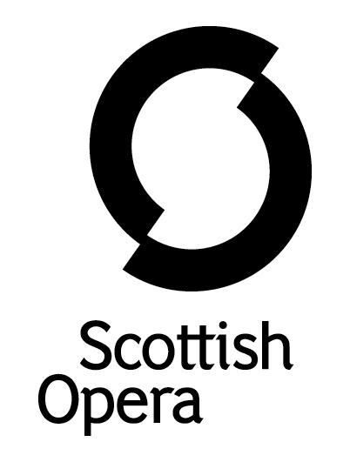

Press Release

17 January 2022

further SESSIONS OF SCOTTISH OPERA’S ONLINE PROJECT BREATH CYCLE, for people SUFFERING FROM LONG COVID AND OTHER breathing difficulties, BEGIN this month
A new block of sessions for Breath Cycle, Scottish Opera’s project designed to benefit those suffering from a range of conditions affecting lung health, in particular Long Covid, begin online on January 26.

Breath Cycle has been highly successful in its first term, with participants reporting improvement in a range of areas, such as anxiety, loneliness and confidence in addition to benefits to their physical health. One said they could ‘already tell (Breath Cycle) will be of great support’ to them, with another adding the online workshops ‘brightened up’ their week.

During a series of relaxed and sociable weekly sessions, a team of musicians from the Company will work with participants introducing them to fun and stimulating songs, vocal exercises and breathing techniques. The benefits of singing regularly are widely recognised, from improved lung function, posture and circulation, to a strengthened immune system and core, better breath control, as well as relief from stress and anxiety. Made with support from key NHS consultants and physiotherapists, the first Breath Cycle sessions took place at the end of last year, and the third block will be in April.

In addition to the singing sessions, those interested in taking part can sign up for new online song writing workshops led by former Scottish Opera composer-in-residence Gareth Williams, and performance poet Martin O’Connor. Whatever the participant’s musical or lyrical style, they will introduce the tools and methods needed to get music out of heads and down on paper.

The songs that come out of these workshops, alongside those created by Gareth and Martin themselves, will be arranged and recorded by Scottish Opera to create a free digital resource for individuals, choirs and singing groups worldwide, called ‘The Covid Composers Songbook’, as a positive musical legacy.

Jane Davidson, Scottish Opera’s Director of Outreach and Education said: ‘We’re delighted to be able to offer the programme for a second term starting in January. The Breath Cycle workshops have proven to be a perfect way for our participants, all of whom suffer from Long Covid or other long term lung conditions, to take a moment for their own wellbeing each week. Working across both singing and song writing workshops led by our highly skilled and experienced professional artists, Breath Cycle group members are able to learn new skills in singing, which enables them to improve breathing and posture. The additional song writing workshops allow participants to explore feelings and emotions related to their physical health and gives anyone who wishes to, the chance to be a songwriter. Most importantly, the programme is fun and delivered in a relaxed way, meaning that group members often take part for social reasons above everything else.’

Gordon MacGregor, Respiratory Consultant at the Department of Respiratory Medicine of Queen Elizabeth University Hospital said: ‘Breath Cycle has been a fantastic project which was first launched in 2013 for people with Cystic Fibrosis. These new sessions provide a platform to work with patients with a range of lung conditions which allows them to exercise their lungs while having fun. This is absolutely key as it keeps them engaged and active in their lung health programme – it’s easy to take part and it’s rewarding.

‘We know how important lung health is to our overall wellbeing, and particularly now, where we’re seeing new patients who may be suffering from breathing issues related to Long Covid, so any treatment which can help address that and offers patients a treatment plan they can stick to, is a positive step.’

The Breath Cycle project was originally created by Scottish Opera and Glasgow’s Gartnavel General Hospital Cystic Fibrosis Service to explore whether learning classical singing techniques, including breath control, could improve the wellbeing of cystic fibrosis patients. Due to the high risk of infection for those with cystic fibrosis, the project also explored how patients might interact safely with each other, using the internet as a means of meeting, learning and building new communities. The materials were created as part of a study into how singing techniques, including breathing exercises could replicate the effects of conventional physiotherapy to increase lung function.

Those interested in signing up for Breath Cycle should contact katie.poulter@scottishopera.org.uk.

Breath Cycle is supported by Cruach Trust, The Murdoch Forrest Charitable Trust, W M Mann Foundation, Souter Charitable Trust and Scottish Opera’s Education Angels.

-ENDS-
www.scottishopera.org.uk
You can follow Scottish Opera on Twitter, Facebook and Instagram @ScottishOpera

Notes to Editors
All productions are created and performed in line with Scottish Government guidelines.
The Company’s Opera on Screen productions are available to watch at: www.scottishopera.org.uk/what-s-on/opera-on-screen/.
The collection includes Donizetti’s L’elisir d’amore, Humperdinck’s Hansel and Gretel, Mozart’s Così fan tutte, Opera Highlights, Janáček’s The Diary of One Who Disappeared, Menotti’s The Telephone and Samuel Bordoli and Jenni Fagan’s The Narcissistic Fish.
Scottish Opera is Scotland’s national opera company and the largest performing arts organisation in Scotland.
The Company's performance repertoire ranges across five centuries, from the earliest operas to newly-commissioned world premieres, working in collaboration with the world's finest singers and creatives, alongside The Orchestra of Scottish Opera and choruses. Recent accolades include a South Bank Sky Arts Award, a Scottish Award for New Music, Sunday Herald Culture Awards and a Herald Angel, as well as a 2020 RPS Award. In 2021 the Company returned to live audiences with Sir David McVicar’s new production of Verdi’s Falstaff performed in Glasgow and at Edinburgh International Festival.
The Company tours extensively across Scotland, from the largest-scale theatres to the smallest of rural venues, to ensure we are within reach of as many of our country's very dispersed population as possible. Our specially-adapted 40-foot long trailer brings ‘Pop-up Opera’ performances to thousands of people each year in a range of inspiring and unexpected community locations. In the summer of 2021 the Company performed nearly 200 shows of its Pop-up Opera Roadshow, to socially distanced audiences of 11,014 people. This is one of the most extensive touring programmes of any European opera company and a much-valued contribution to Scotland’s cultural and artistic life, particularly in remote and island communities.
The Company’s Education and Outreach programme, which celebrates 50 years in 2021, includes an annual Primary Schools Tour, bringing upper primary-aged children the opportunity to perform their own specially-commissioned piece, alongside three professional singers. Around 120 schools and 9,000 pupils take part each year.
Scottish Opera aims to be inclusive and affordable through availability of free and cheap tickets, as well as performances offering audio description, and specially-devised shorter access performances.
Scottish Opera is core funded by The Scottish Government

For additional press details please contact:
Emily Henderson, Press Manager, 0141 2420511,emily.henderson@scottishopera.org.uk
Julie McLaughlin, Press Officer, 0141 242 0552, julie.mclaughlin@scottishopera.org.uk

