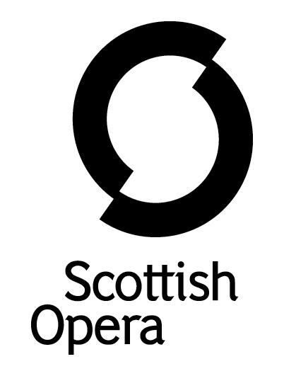

Press Release

22 July 2021

SCOTTISH OPERA’s Young Company Presents the scottish premiere of kurt weill’s the tsar has his photograph taken

Scottish Opera’s Young Company, a training programme for 17 to 23 year olds, is thrilled to be back performing live outdoors as part of Live at No. 40 at Scottish Opera’s Production Studio car park, 40 Edington Street in Glasgow. Directed by Roxana Haines (La bohème 2020, Così fan tutte 2020, L’elisir d’amore 2021), the Young Company performs the Scottish premiere of Kurt Weill’s bold and absurd one-act comedy, The Tsar Has His Photograph Taken, on 31 July and 1 August 2021.
With Aidan Edwards and Shuna Scott Sendall in lead roles, Scottish Opera Young Company Artistic Director – Chris Gray – conducts the young performers through this farcical tale, with stage designs by Anna Orton, libretto by Georg Kaiser, and in an English translation by Leo Doulton.
The popularity of Weill’s work in Germany during the late 1920’s/early1930’s fell dramatically in direct correlation to the rise of National Socialism. As a prominent Jewish artist, many performances of Weill’s work were subjected to violent disruption by Nazi extremists and were forced to close. Kurt Weill left Germany in 1933, never to return, and spent the remainder of his life and career in the USA. A significant number of pieces he had composed in the years immediately preceding his exile were never produced elsewhere. As a result, the first UK performance of The Tsar Has His Photograph Taken (which was composed in 1927) did not take place until 1986 at the Bloomsbury Theatre, London. This production is the Scottish premiere.
As a composer who believed that his music should serve a social purpose on one or more levels, the Scottish Opera Young Company present this one-act operatic comedy as a fascinating glimpse into the darker side of fame (even by the standards of the jazz age) and social media, asking a question that has enormous resonance with today’s audiences – just how dangerous can a camera can be?
The story is set in Madame Angèle’s photo studio in Paris. She receives a phone call telling her the Tsar will be arriving shortly to have his photograph taken, but nobody knows who invited him. What unfolds is that a gang are planning an assassination attempt on the Tsar. Director Roxana Haines takes a present-day approach to the slapstick and humour that frames the story, including fake news and bringing objects to life.
Roxana explains: ‘Georg Kaiser was an expressionist playwright, collaborating with Kurt Weill in a time when reality couldn't express the horrors and chaos of the world through words. We've utilised this to make roles for our young company, with personified inanimate objects emoting in the photography studio, and a fake news team commenting with emojis and trying to catch the assassination shot. The setting has been modernised to a time where everyone is watching everyone else, through live camera feeds, cctv and silly bugging devices. The show is absurd, unapologetic and joyful, with, for example, the lingering sense of an episode of Charlie Brooker's Black Mirror.’
The Young Company has been rehearsing online during the pandemic, and in the past few months have come together for socially distanced rehearsals. This will be the first time the group is able to perform live for an audience.
Scottish Opera Young Company Artistic Director, Chris Gray, said: ‘This has been the perfect piece to bring SOYC back to the stage after 18 months away. They have worked with boundless energy, enthusiasm and commitment to overcome the many challenges of creating a safe, socially distanced performance in which to bring this little-known gem to life! It has been inspiring to see them work, this is a performance not to be missed.’
Scottish Opera Young Company not only offers young singers the opportunity to work with opera professionals but also gives young stage managers aged 16 to 19 a unique and practical introduction to the world of opera and stage management.
This production is kindly supported by The Hugh Fraser Foundation, The Carntyne Trust, John S Cohen Foundation, Gordon Fraser Charitable Trust, The Russell Trust and Scottish Opera’s Education Angels.
Tickets available to buy online now at scottishopera.org.uk.
Notes to Editors
All productions are created and performed in line with Scottish Government guidelines. Refunds are guaranteed should a performance not be able to go ahead. Detailed Covid safety guidance will be issued when tickets go on sale.
Performances will take place at Scottish Opera’s Production Studio car park: 40 Edington St, Glasgow G4 9RD.
The Company’s Opera on Screen productions are available to watch at: www.scottishopera.org.uk/what-s-on/opera-on-screen/.
The collection includes Donizetti’s L’elisir d’amore, Humperdinck’s Hansel and Gretel, Mozart’s Così fan tutte, Opera Highlights, Janáček’s The Diary of One Who Disappeared, Menotti’s The Telephone and Samuel Bordoli and Jenni Fagan’s The Narcissistic Fish.
Scottish Opera is Scotland’s national opera company and the largest performing arts organisation in Scotland.
The Company's performance repertoire ranges across five centuries, from the earliest operas to newly-commissioned world premieres, working in collaboration with the world's finest singers and creatives, alongside The Orchestra of Scottish Opera and choruses. Recent accolades include a South Bank Sky Arts Award, a Scottish Award for New Music, Sunday Herald Culture Awards and a Herald Angel, as well as a 2020 RPS Award
The Company tours extensively across Scotland, from the largest-scale theatres to rural venues with a capacity as low as 22, to ensure we are within reach of as many of our country's very dispersed population as possible. A miniature mobile opera house – literally, opera performed inside a converted 40-foot-long trailer on the back of a lorry – brings ‘Pop-up Opera’ performances to thousands of people each year in a range of inspiring and unexpected community locations. This represents the most extensive touring programme of any opera company in Europe and is a much-valued contribution to Scotland’s cultural and artistic life, particularly in remote and island communities.

The Company’s Education and Outreach programme, which celebrates 50 years in 2021, includes an annual Primary Schools Tour, bringing upper primary-aged children the opportunity to perform their own specially-commissioned piece, alongside three professional singers. Around 120 schools and 9,000 pupils take part each year.

Scottish Opera aims to be inclusive and affordable through availability of free and cheap tickets, as well as access performances including audio description, and performances which cater to those living with Dementia.

Scottish Opera is core funded by The Scottish Government

