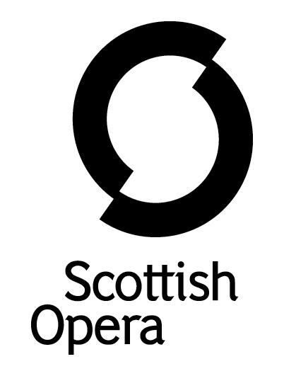

Press Release

25 September 2020

SCOTTISH OPERA ACQUIRES THE DISTINGUISHED D’OYLY CARTE MUSIC HIRE LIBRARY

Scottish Opera is delighted to be working with D’Oyly Carte Opera to bring the extensive music hire library of Gilbert and Sullivan works to its Elmbank Crescent offices in Glasgow, which also houses an extensive library of scores, orchestral and vocal parts.
The music hire library provides orchestral parts and other musical material to anyone in the UK and Europe looking to perform Gilbert and Sullivan, including professional companies, amateur dramatic societies, and school groups.
Scottish Opera acquired 86 crates of music from D’Oyly Carte which have taken three weeks to sort through. This will be the only location to hire the material from the original performers of Gilbert and Sullivan, with some of the rarer items being sent down to join the D’Oyly Carte collection in the British Library.
By hiring the material from Scottish Opera, companies will have the opportunity to buy into the great tradition of amateur performance and access the original D’Oyly Carte works of Gilbert and Sullivan. D’Oyly Carte parts available to hire include some of the rarer works such as Utopia, Limited, The Grand Duke, shows that Sullivan wrote without Gilbert, as well as the more well-known works such as Trial by Jury, HMS Pinafore, The Pirates of Penzance, Iolanthe, The Mikado, The Yeomen of the Guard, and The Gondoliers.
Scottish Opera has worked with D’Oyly Carte Opera Company since 2013, co-producing productions of Gilbert and Sullivan’s The Pirates of Penzance, The Mikado and were due to have productions of The Gondoliers and Utopia Limited this year.
During lockdown the Company has delved in to the whimsical world of Gilbert and Sullivan with their Spotlight on The Gondoliers. An online project which looks further in to the musical intricacies of Gilbert and Sullivan's comic opera, as well as featuring performances, in-depth articles and exclusive archive photography- available at the Scottish Opera website: https://www.scottishopera.org.uk/discover-opera/spotlight-on-the-gondoliers/
Scottish Opera Head of Music, Derek Clark said: ‘It's not often that an opera company gets the chance to help another opera company, so it's great for Scottish Opera to be able to offer the space and the manpower to take over the running of the D'Oyly Carte library. For me, personally, as a lifelong Gilbert and Sullivan devotee, it is wonderful to have this resource available to explore - it's a bit like being let loose in Aladdin's cave. So, I’m very much looking forward to seeing whether any undiscovered gems lie lurking in its depths.’
D'Oyly Carte Opera Trust General Manager, Ian Martin said: ‘I'm really happy that the D'Oyly Carte Music Hire Library is to be managed by Scottish Opera. Our co-producing partnership with Scottish Opera has been successful for over seven years now and we still have our greatest project to look forward to. I have looked after the library for over 32 years now and have moved it no less than seven times to various addresses around the UK- London, Birmingham and Wolverhampton. I hope that it has found a more stable and consistent home now and for the future.’
Scottish Opera Music Librarian, Gordon Grant said: ‘I’m excited to take over the running of the D’Oyly Carte Music Hire Library and I can’t think of a better project to work on until we can return to doing what we do best – putting on shows. We, at Scottish Opera, are a company who knows first-hand the joy of performing Gilbert and Sullivan’s operas, so it’s fantastic to be able to share our enthusiasm by providing sheet music to performing societies and organisations across the UK and Europe. By hiring from The D’Oyly Carte Music Hire Library, you are also helping both Scottish Opera and D’Oyly Carte bring you more brilliant opera.’
-ENDS-
www.scottishopera.org.uk
Notes to Editors
The Gilbert and Sullivan operas available to hire

Trial by Jury, The Sorcerer, HMS Pinafore, The Pirates of Penzance Patience, Iolanthe, Princess Ida, The Mikado, Ruddigore, The Yeomen of the Guard, The Gondoliers Utopia Limited , The Grand Duke

Other Sullivan operas available
Cox and Box
Haddon Hall

Other operas available
Die Fledermaus, translated by Alistair Beaton
La vie Parisienne, translated by Alistair Beaton

Please contact Music Librarian, gordon.grant@scottishopera.org.uk for more information on music hire.

Find out more about the Gilbert and Sullivan operas and D’Oyly Carte at http://www.doylycarte.org.uk

Scottish Opera is Scotland’s national opera company and the largest performing arts organisation in Scotland. It was founded by Alexander Gibson in 1962 and was inaugurated with a production of Madama Butterfly at the King's Theatre in Glasgow.
Notable achievements include the world premiere of James MacMillan's Inés de Castro at the 1996 Edinburgh International Festival; complete Ring cycles at the 2003 Edinburgh International Festival, which won the 2004 South Bank Show Award for Best Opera Production; and the Achievement in Opera Award at the 2017 UK Theatre Awards for Sir David McVicar’s production of Debussy’s Pelléas and Mélisande. Recent commissions include Five:15 Operas Made in Scotland (2008-10); The Lady from the Sea, Clemency, the double bill of In the Locked Room and Ghost Patrol (winner of a South Bank Sky Arts Award) which premiered at the 2012 Edinburgh International Festival and 2016's The Devil Inside by Stuart MacRae and Louise Welsh. Earlier this year the Company made its US debut with BambinO at the Metropolitan Opera New York, and returns to the city’s Brooklyn Academy of Music with Greek in December.
Scottish Opera is committed to bringing the widest possible range of opera, performed to the highest possible standards, to the maximum audience throughout Scotland and the UK. Each year it performs in Glasgow, Edinburgh, Aberdeen and Inverness, as well as smaller theatres, village halls and community centres throughout the country.
Scottish Opera’s Education and Outreach Department was the first of its kind of any opera company in Europe. It operates an extensive programme which involves over 8,000 primary school children every year as well as many other activities including adult learning and Unwrapped taster sessions.
Scottish Opera is supported by the Scottish Government.

For additional press details please contact:
Julie McLaughlin, Press Officer, 07825981241, julie.mclaughlin@scottishopera.org.uk

