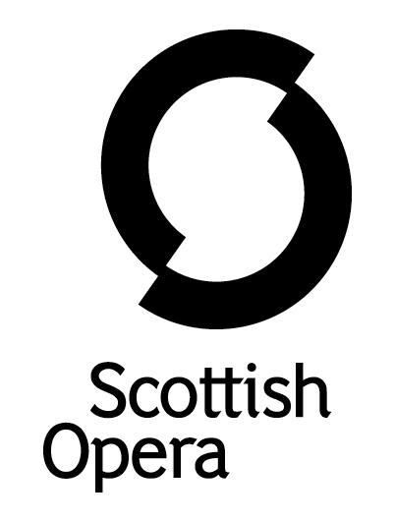

Press Release

12 October 2022

SCOTTISH OPERA PRESENTS THE VERDI COLLECTION IN ABERDEEN, INVERNESS, GLASGOW AND EDINBURGH

As part of the Opera in Concert series, Scottish Opera presents The Verdi Collection, a selection of the Italian composer’s greatest hits at His Majesty’s Theatre, Aberdeen on 19 November and Eden Court, Inverness on 26 November, with the concert then touring to City Halls, Glasgow and Usher Hall, Edinburgh in February 2023.
A cast of internationally acclaimed singers bring numerous roles to life, capturing the breadth and drama of Verdi’s incredible array of popular operas that earned him the title of the “king” of all Italian opera composers. In Aberdeen and Inverness, Scottish Opera’s Music Director Stuart Stratford conducts The Orchestra of Scottish Opera along with the cast including Hye-Youn Lee (Don Giovanni 2022), Christopher Turner (La traviata 2017), Roland Wood (Don Giovanni 2022) and Jihoon Kim. In 2023, the concert travels to Glasgow and Edinburgh with Eri Nakamura, Peter Auty (Eugene Onegin 2018), Lester Lynch (Silvano 2019) and Brindley Sherratt (Inês de Castro 2015).
Capturing the romance, passion and tragedy of Verdi’s works, the concert features a playlist from operas including La traviata, Un ballo in maschera, La forza del destino, Don Carlo, Otello and Macbeth. In an evening of dramatic storytelling this is a chance to hear some the composer’s more iconic music, recognisable from numerous TV adverts and films.
Known for his beautiful melodies and powerful plots, complicated relationships sit at the heart of his operas, as the concert’s singers become families, lovers, friends and enemies who often find themselves at dramatic odds, with understandable motives on all sides.
Scottish Opera Music Director Stuart Stratford said: ‘The Verdi Collection comprises some of the highlights of the composer’s middle and late period from La traviata, one of the most popular operas, to Don Carlo and Otello.
‘The orchestra increasingly becomes more of an independent dramatic voice in his later works, with the sinister bassoon counterpoint in Otello and the golden aura of the cornets in Don Carlo striking examples of colour and character.
‘We hope there is something in The Verdi Collection for everyone and that the great Italian master still surprises us today as he undoubtedly did when these works were first performed.’
Verdi’s prolific output was marked by many styles, themes, and stories in a career that spanned over 50 years. At the heart of all his operas are instantly recognisable characters (noble heroes and dastardly villains alike), nuanced relationships between lovers and families, and melodies that transcend time.
The Verdi Collection is supported by Friends of Scottish Opera and The Scottish Opera Endowment Trust.
Tickets are on sale now at www.scottishopera.org.uk/shows/the-verdi-collection/
You can follow Scottish Opera on Facebook, Twitter and Instagram @ScottishOpera

Creative Team
Conductor Stuart Stratford
Cast
Aberdeen and Inverness performances
Soprano Hye-Youn Lee
Tenor Christopher Turner
Baritone Roland Wood
Bass Jihoon Kim

Glasgow and Edinburgh performances
Soprano Eri Nakamura
Tenor Peter Auty
Baritone Lester Lynch
Bass Brindley Sherratt

Performance Diary
The Verdi Collection
His Majesty’s Theatre, Aberdeen
19 November, 7.30pm
Eden Court, Inverness
26 November, 7.30pm
City Halls, Glasgow
10 February 2023, 7.30pm
Usher Hall, Edinburgh
11 February 2023, 7.30pm

-ENDS-
www.scottishopera.org.uk

Notes to Editors
Scottish Opera is Scotland’s national opera company and the largest performing arts organisation in Scotland. The 2022/23 season marks its 60th Anniversary.

The Company’s performance repertoire ranges across five centuries, from the earliest operas to newly-commissioned world premieres. Scottish Opera collaborates with the world’s finest singers and creatives, together with The Orchestra of Scottish Opera and choruses for each opera. Recent accolades include a South Bank Sky Arts Award, a Scottish Award for New Music, Sunday Herald Culture Awards, a Herald Angel, and a 2020 RPS Award. In 2021 the Company returned to live audiences with Sir David McVicar’s new production of Verdi’s Falstaff performed in Glasgow and at the Edinburgh International Festival.

The Company tours extensively across Scotland to ensure performances are within reach of as many of the country’s very dispersed population as possible. Specially-adapted 40-foot long trailers bring Pop-up Opera performances to thousands of people each year. In 2021 the Company performed nearly 200 performances of its Pop-up Opera Roadshow to socially distanced audiences of 11,014 people. This is one of the most extensive touring programmes of any European opera company and a much-valued contribution to Scotland’s cultural and artistic life, particularly in remote and island communities.

The Company’s Education & Outreach programme, which celebrated 50 years in 2021, includes an annual Primary Schools Tour, bringing children the opportunity to perform their own specially-commissioned piece alongside professional singers. Around 120 schools and 9,000 pupils take part each year. Scottish Opera aims to be inclusive and affordable through availability of free and cheap tickets, as well as performances offering audio description and specially-devised shorter access performances.

The Company’s Opera on Screen productions are available to watch at: www.scottishopera.org.uk/what-s-on/opera-on-screen. The collection includes Donizetti’s L’elisir d’amore, Humperdinck’s Hansel and Gretel, Mozart’s Così fan tutte, Opera Highlights, Menotti’s The Telephone, and Samuel Bordoli and Jenni Fagan’s The Narcissistic Fish. The Company’s 2021 production of The Gondoliers, filmed live at Festival Theatre Edinburgh, is available on BBC iPlayer.

For additional press details please contact the Scottish Opera press office:
Emily Henderson, Press Manager, 0141 242 0511, emily.henderson@scottishopera.org.uk
Julie McLaughlin, Press Officer, 0141 242 0552, julie.mclaughlin@scottishopera.org.uk

