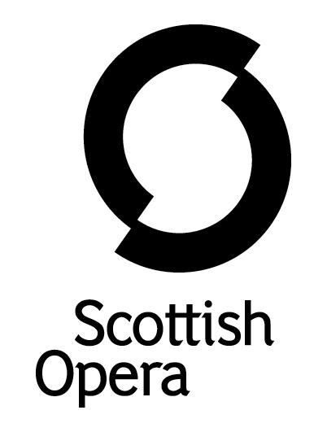

Press Release

2 February 2022

SCOTTISH OPERA welcomes first minister nicola sturgeon to its glasgow production studios to MARK the relaxAtion of covid restrictions in the entertainment sector

Today (2 February), First Minister Nicola Sturgeon visited Scottish Opera’s Production Studios in Glasgow, to mark the recent relaxation of COVID restrictions in Scotland’s entertainment sector.

The First Minister was taken on a tour of the Edington Street building, which was purpose built in 1997 to house the Company’s technical and education departments, by Scottish Opera General Director, Alex Reedijk and Chairman, Peter Lawson. She spent time in the rehearsal room of the new production of Benjamin Britten’s A Midsummer Night’s Dream, which is directed by Dominic Hill and opens at Theatre Royal Glasgow on February 22. The cast and creative team of the show met with the First Minister, as did members of the children’s chorus, who range in age from nine to 13, and are from all over Scotland.

She also met with many of the skilled artisans that form the backbone of Scotland’s vibrant live theatre and opera scene as well as feed into the film sector, including carpenters, metal workers, scenic painters, designers, props, costume and wig makers as well as make-up artists. This is an important and growing industry in Scotland with many opportunities for young people to develop their craft.

Also during the visit, Jane Davidson, the Company’s Director of Outreach and Education, chatted to the First Minister about Breath Cycle, Scottish Opera’s online project designed to benefit those suffering from a range of conditions affecting lung health, in particular Long COVID. Made with support from key NHS consultants and physiotherapists, the second block of Breath Cycle began last week following the success of the first sessions in 2021.

First Minister Nicola Sturgeon said: ‘Today I have seen just how many skilled jobs a production like this supports; the players on stage, the people working behind the scenes on set design and costume, and the countless hours they pour into bringing a production like A Midsummer Night’s Dream to life. It is remarkable too that Scottish Opera is able to use its breathing training to help people suffering from Long COVID, which we know can’t be handled with a one-size-fits-all approach, so to hear the difference this innovative approach is making is hugely impressive.

‘I am immensely grateful to everyone who complied with the protective measures which have been in force in recent months - it is because of those collective efforts that we are now able to get back to concerts, shows, sporting occasions and other events. I would urge everyone who is able to support productions like this to do so - you will be supporting the livelihoods of the many skilled artists who work in our vital performing arts industry.’

Alex Reedijk, Scottish Opera General Director said: ‘After a tough couple of years, the recent announcement regarding the relaxation of restrictions was very welcome for all of us in the entertainment sector across Scotland. Ours is such a huge industry, with lockdown affecting so many artists, singers, musicians, and backstage workers and makers.

‘Throughout the pandemic, we at Scottish Opera worked hard to adapt our performances, moving them both online and outdoors, but I must say it’s a real delight to at last be back in theatres. We will continue to put the safety of our audiences first, with enhanced ventilation and the mandatory wearing of masks in our venues.

‘As well as A Midsummer Night’s Dream, we have a busy programme of performances coming up, including an 18-venue Opera Highlights tour, a Primary Schools Tour of The Last Aliens that travels all over Scotland from Glasgow to Shetland, as well as our Breath Cycle and Memory Spinners sessions. We hope as many people as possible can join us for these fantastic shows.’

-ENDS-
www.scottishopera.org.uk

You can follow Scottish Opera on Twitter, Facebook and Instagram @ScottishOpera

Notes to Editors

All productions are created and performed in line with Scottish Government guidelines.
The Company’s Opera on Screen productions are available to watch at: www.scottishopera.org.uk/what-s-on/opera-on-screen/.
The collection includes Donizetti’s L’elisir d’amore, Humperdinck’s Hansel and Gretel, Mozart’s Così fan tutte, Opera Highlights, Janáček’s The Diary of One Who Disappeared, Menotti’s The Telephone and Samuel Bordoli and Jenni Fagan’s The Narcissistic Fish. Scottish Opera is Scotland’s national opera company and the largest performing arts organisation in Scotland.
The Company's performance repertoire ranges across five centuries, from the earliest operas to newly-commissioned world premieres, working in collaboration with the world's finest singers and creatives, alongside The Orchestra of Scottish Opera and choruses. Recent accolades include a South Bank Sky Arts Award, a Scottish Award for New Music, Sunday Herald Culture Awards and a Herald Angel, as well as a 2020 RPS Award. In 2021 the Company returned to live audiences with Sir David McVicar’s new production of Verdi’s Falstaff performed in Glasgow and at Edinburgh International Festival.
The Company tours extensively across Scotland, from the largest-scale theatres to the smallest of rural venues, to ensure we are within reach of as many of our country's very dispersed population as possible. Our specially-adapted 40-foot long trailer brings ‘Pop-up Opera’ performances to thousands of people each year in a range of inspiring and unexpected community locations. In the summer of 2021 the Company performed nearly 200 shows of its Pop-up Opera Roadshow, to socially distanced audiences of 11,014 people. This is one of the most extensive touring programmes of any European opera company and a much-valued contribution to Scotland’s cultural and artistic life, particularly in remote and island communities.
The Company’s Education and Outreach programme, which celebrates 50 years in 2021, includes an annual Primary Schools Tour, bringing upper primary-aged children the opportunity to perform their own specially-commissioned piece, alongside three professional singers. Around 120 schools and 9,000 pupils take part each year.

Scottish Opera aims to be inclusive and affordable through availability of free and cheap tickets, as well as performances offering audio description, and specially-devised shorter access performances.
Scottish Opera is core funded by The Scottish Government.

For additional press details please contact:
Emily Henderson, Press Manager, 0141 242 0511,emily.henderson@scottishopera.org.uk
Julie McLaughlin, Press Officer, 0141 242 0552, julie.mclaughlin@scottishopera.org.uk

