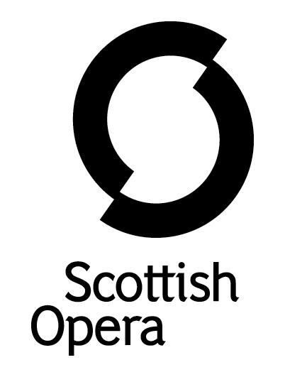

Press Release

12 October 2021

SCOTTISH OPERA COMES TO DUNDEE’S CAIRD HALL IN DECEMBER WITH
THE PUCCINI COLLECTION CONCERT

On Sunday 12 December, there is the chance to celebrate the festive season with Scottish Opera in Dundee’s Caird Hall. Conducted by the Company’s Music Director, Stuart Stratford, The Puccini Collection features favourite arias, ensembles and orchestral interludes from Giacomo Puccini’s timeless operas. Soloists Roland Wood (Falstaff 2021), Sinéad Campbell-Wallace (Tosca 2019), David Junghoon Kim (making his Company debut), and Scottish Opera Emerging Artist 2021/22 Catriona Hewitson (Così fan tutte 2021) will be accompanied on stage by the Orchestra of Scottish Opera.

Featuring excerpts from well-known and well-loved works including Tosca ‘(‘Vissi d’arte’), Turandot (‘Nessun Dorma’) and La bohème, as well as rarer gems from La Fanciulla del West, Manon Lescaut, and Edgar, there is plenty for newcomers and aficionados alike.

Scottish Opera Music Director, Stuart Stratford said: ‘There is a reason why Puccini is one of the greatest opera composers - sumptuous harmony supporting memorable melodic lines, all steeped in the character and situation of the most moving stories. The Puccini Collection contains some of the most breathtaking spans of operatic writing in the repertoire not to be missed.

‘Audiences have the chance to see some wonderful performers too: Roland Wood is established as Britain’s finest dramatic baritone, and we are lucky to have a close working relationship with him. Sinéad Campbell-Wallace was sensational in our 2019 production of Tosca, and is fast becoming one of the UK’s most desirable sopranos. It is the first time that David Junghoon Kim has worked for Scottish Opera and we are thrilled to have him. And finally, Catriona Hewitson, our Emerging Artist soprano delighted audiences during lockdown with her Adina from L'elisir d'amore, which is still available to watch on our website.’

Tickets are on sale from 12 October at Dundee Box Office, priced £27 / £21 with £10 for Under 26s.

You can follow Scottish Opera on Facebook, Twitter and Instagram @ScottishOpera

-ENDS-

The Puccini Collection

Conductor Stuart Stratford
Sopranos Sinéad Campbell-Wallace & Catriona Hewitson*
Tenor David Junghoon Kim
Baritone Roland Wood

*Scottish Opera Emerging Artist 2021/22
Performance dates and venues
Sunday 12 December, 7.30pm, Caird Hall, City Square, Dundee, DD1 3B
Notes to Editors

All productions are created and performed in line with Scottish Government guidelines.
The Company’s Opera on Screen productions are available to watch at: www.scottishopera.org.uk/what-s-on/opera-on-screen/.
The collection includes Donizetti’s L’elisir d’amore, Humperdinck’s Hansel and Gretel, Mozart’s Così fan tutte, Opera Highlights, Janáček’s The Diary of One Who Disappeared, Menotti’s The Telephone and Samuel Bordoli and Jenni Fagan’s The Narcissistic Fish.
Scottish Opera is Scotland’s national opera company and the largest performing arts organisation in Scotland.
The Company's performance repertoire ranges across five centuries, from the earliest operas to newly-commissioned world premieres, working in collaboration with the world's finest singers and creatives, alongside The Orchestra of Scottish Opera and choruses. Recent accolades include a South Bank Sky Arts Award, a Scottish Award for New Music, Sunday Herald Culture Awards and a Herald Angel, as well as a 2020 RPS Award. In 2021 the Company returned to live audiences with Sir David McVicar’s new production of Verdi’s Falstaff performed in Glasgow and at Edinburgh International Festival.
The Company tours extensively across Scotland, from the largest-scale theatres to the smallest of rural venues, to ensure we are within reach of as many of our country's very dispersed population as possible. Our specially-adapted 40-foot long trailer brings ‘Pop-up Opera’ performances to thousands of people each year in a range of inspiring and unexpected community locations. In the Summer of 2021 the Company performed over 200 shows of its Pop-up Opera Roadshow, to socially distanced audiences of over 8000. This represents the most extensive touring programme of any opera company in Europe and is a much-valued contribution to Scotland’s cultural and artistic life, particularly in remote and island communities.
The Company’s Education and Outreach programme, which celebrates 50 years in 2021, includes an annual Primary Schools Tour, bringing upper primary-aged children the opportunity to perform their own specially-commissioned piece, alongside three professional singers. Around 120 schools and 9,000 pupils take part each year.
Scottish Opera aims to be inclusive and affordable through availability of free and cheap tickets, as well as performances offering audio description, and specially-devised shorter access performances.
Scottish Opera is core funded by The Scottish Government
For additional press details please contact:
Emily Henderson, Press Manager, 0141 242 0511,emily.henderson@scottishopera.org.uk
Julie McLaughlin, Press Officer, 0141 242 0552, julie.mclaughlin@scottishopera.org.uk

