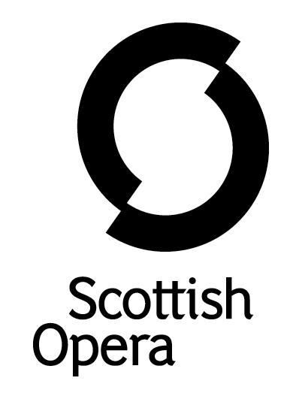

Press Release

30 September 2021

SCOTTISH OPERA LAUNCHES NEW ONLINE PROJECT BREATH CYCLE for people SUFFERING FROM LONG COVID AND THOSE with breathing difficulties
Breath Cycle, Scottish Opera’s new project designed to benefit those suffering from a range of conditions affecting lung health, in particular Long Covid, begins online in October.

During a series of relaxed weekly sessions, a team of musicians from the Company will work with participants introducing them to fun and stimulating songs, vocal exercises and breathing techniques. The benefits of singing regularly are widely recognised, from improved lung function, posture and circulation, to a strengthened immune system and core, better breath control, as well as relief from stress and anxiety. Made with support from key NHS consultants, the first Breath Cycle sessions start on 20 October, and will be repeated in blocks in January and April 2022.

In addition to the singing sessions, those interested in taking part can sign up for new online song writing workshops led by former Scottish Opera composer-in-residence Gareth Williams, and performance poet Martin O’Connor. Whatever the participant’s musical or lyrical style, they will introduce the tools and methods needed to get music out of heads and down on paper.

The songs that come out of these workshops, alongside those created by Gareth and Martin themselves, will be arranged and recorded by Scottish Opera to create a free digital resource for individuals, choirs and singing groups worldwide, called ‘The Covid Composers Songbook’, as a positive musical legacy of the past 18 months.

Jane Davidson, Scottish Opera’s Director of Outreach and Education said: ‘COVID-19 has affected us all in different ways. But if, like many, it has impacted your long-term physical health, we want to help. Singing is the perfect work out for your heart, lungs, and even your brain. According to the British Lung Foundation, regular singing can have similar benefits to physiotherapy: teaching you to breathe more slowly and deeply; improving your sense of control over your breathing, which in turn reduces anxiety and potential feelings of panic; and improving posture to help you breathe more efficiently. Not only that, but joining a group like this can also introduce you to a network of likeminded people facing similar challenges – all in one enjoyable, sociable and rewarding experience!’

The Breath Cycle project was originally created in 2013 by Scottish Opera and Glasgow’s Gartnavel General Hospital Cystic Fibrosis Service to explore whether learning classical singing techniques, including breath control, can improve the wellbeing of cystic fibrosis patients. Due to the high risk of infection for those with cystic fibrosis, the project also explored how patients might interact safely with each other, using the internet as a means of meeting, learning and building new communities. The materials were created as part of a study into how singing techniques, including breathing exercises could replicate the effects of conventional physiotherapy to increase lung function.

Those interested in signing up for the sessions should register by 13 October, by visiting www.scottishopera.org.uk/join-in/breath-cycle/

The singing sessions will take place on Wednesdays, at 12.30-1.30pm, from 20 October to 22 December. The song writing sessions are on Fridays from 12.30-1.30pm, on 29 October, 12 November, 26 November, 10 December and 17 December. All sessions are free and online via Zoom.

Breath Cycle is supported by Cruach Trust, The Murdoch Forrest Charitable Trust, W M Mann Foundation, Souter Charitable Trust and Scottish Opera’s Education Angels.

-ENDS-
www.scottishopera.org.uk
You can follow Scottish Opera on Twitter, Facebook and Instagram @ScottishOpera

Notes to Editors
The Company’s Opera on Screen productions are available to watch at: www.scottishopera.org.uk/what-s-on/opera-on-screen/.
The collection includes Donizetti’s L’elisir d’amore, Humperdinck’s Hansel and Gretel, Mozart’s Così fan tutte, Opera Highlights, Janáček’s The Diary of One Who Disappeared, Menotti’s The Telephone and Samuel Bordoli and Jenni Fagan’s The Narcissistic Fish.
Scottish Opera is Scotland’s national opera company and the largest performing arts organisation in Scotland.
The Company's performance repertoire ranges across five centuries, from the earliest operas to newly-commissioned world premieres, working in collaboration with the world's finest singers and creatives, alongside The Orchestra of Scottish Opera and choruses. Recent accolades include a South Bank Sky Arts Award, a Scottish Award for New Music, Sunday Herald Culture Awards and a Herald Angel, as well as a 2020 RPS Award. In 2021 the Company returned to live audiences with Sir David McVicar’s new production of Verdi’s Falstaff performed in Glasgow and at Edinburgh International Festival.
The Company tours extensively across Scotland, from the largest-scale theatres to the smallest of rural venues, to ensure we are within reach of as many of our country's very dispersed population as possible. Our specially-adapted 40-foot long trailer brings ‘Pop-up Opera’ performances to thousands of people each year in a range of inspiring and unexpected community locations. In the Summer of 2021 the Company performed over 200 shows of its Pop-up Opera Roadshow, to socially distanced audiences of over 8000. This represents the most extensive touring programme of any opera company in Europe and is a much-valued contribution to Scotland’s cultural and artistic life, particularly in remote and island communities.
The Company’s Education and Outreach programme, which celebrates 50 years in 2021, includes an annual Primary Schools Tour, bringing upper primary-aged children the opportunity to perform their own specially-commissioned piece, alongside three professional singers. Around 120 schools and 9,000 pupils take part each year.
Scottish Opera aims to be inclusive and affordable through availability of free and cheap tickets, as well as performances offering audio description, and specially-devised shorter access performances.
Scottish Opera is core funded by The Scottish Government
For additional press details please contact:
Emily Henderson, Press Manager, 0141 242 0511,emily.henderson@scottishopera.org.uk
Julie McLaughlin, Press Officer, 0141 242 0552, julie.mclaughlin@scottishopera.org.uk

