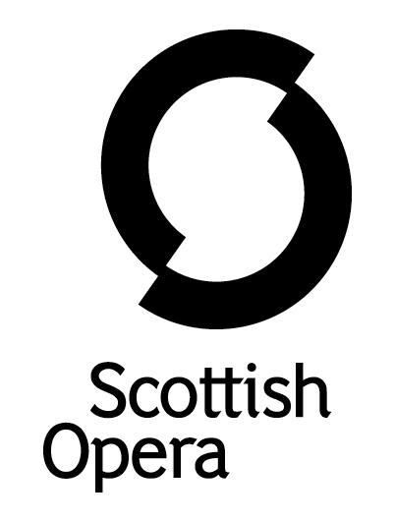

Press Release

17 August 2021

SCOTTISH OPERA RETURNS INDOORS TO LOCAL VENUES FOR OPERA HIGHLIGHTS THIS AUTUMN

On September 14, Scottish Opera’s hugely popular Opera Highlights tour kicks off, journeying the length and breadth of Scotland to nine venues for a total of 11 performances.
This will be the first time in 18 months that Scottish Opera has been able to perform inside local venues for a live audience. The Opera Highlights tour is at the heart of the Company’s ethos to deliver opera to local communities, making it accessible to all.

Following last year’s online Opera Highlights, this year the tour returns to venues in Greenock, Musselburgh, St Andrews, Ballachullish, Strathpeffer, Stornoway, Peebles, Ayr and Dunoon. With performances indoors, there will be reduced audience numbers to allow communities to once again safely enjoy the live opera experience in their own venues.

Opera Highlights is an opportunity to hear a whole range of music in just one evening. This heartfelt hour-long show is full of fun and bittersweet comedy featuring a playlist of much loved classics, curated by Scottish Opera’s Head of Music Derek Clark, from Carmen, Don Giovanni and Gounod's Romeo et Juliette, alongside some lesser-known gems. Using a selection of opera's greatest love stories, Director Jeanne Pansard-Besson’s production follows two couples reflecting on the pivotal moments of their relationships, celebrating the passion, happiness, silliness and sadness that come with love and reveling in the human emotions and feelings that we all experience.

Soprano Meinir Wyn Roberts and baritone Seán Boylan are joined by Scottish Opera 2021/22 Emerging Artists, mezzo-soprano Lea Shaw and tenor Glen Cunningham, with accompaniment on piano by Musical Director Fiona MacSherry.

Director, Jeanne Pansard-Besson, said: ‘In this Opera Highlights, everyone says I love you. Fragments of very different operas across time and space show all the different states of being in love and in a relationship, from the extreme highs to the extreme lows. And this is what opera is about: it expresses and reveals all human emotions, all the feelings that we all feel, have felt, and will feel. Hard not to fall in love with opera after this!’

Scottish Opera General Director, Alex Reedijk, said: ‘We are delighted that we can finally return to live indoor performance across Scotland. Opera Highlights was our last live performance before the pandemic and last year we were only able to offer our Autumn tour through a short film. So, this is the first time in nearly two years that we are able to tour with a new live Opera Highlights carefully curated by our wonderful Head of Music, Derek Clark. The Opera Highlights productions are always so well received by local audiences of all ages and it is a great opportunity to see some of our talented young singers performing. We can’t wait to get back out on the road bringing live opera to far-flung audiences across Scotland.’

Opera Highlights is supported by The Friends of Scottish Opera, The Scottish Opera Endowment Trust and The JTH Charitable Trust.
Tickets are on sale from 10am on Tuesday 17 August at www.scottishopera.org.uk and for the first time are free for under 18s.
You can follow Scottish Opera on Facebook, Twitter and Instagram @ScottishOpera

ENDS

Opera Highlights Cast and Creative Team

Director Jeanne Pansard-Besson
Soprano Meinir Wyn Roberts
Mezzo-soprano Lea Shaw
Tenor Glen Cunningham
Baritone Seán Boylan
Musical Director/Pianist Fiona MacSherry
Performance dates and venues
Tuesday 14 Sep, 7pm, The Beacon Arts Centre, Greenock
Thursday 16 Sep, 7pm, The Brunton Theatre, Musselburgh
Saturday 18 Sep, 2.30pm and 7.30pm, The Byre, St Andrews
Tuesday 21 Sep, 7pm, Ballachulish Village Hall
Thursday 23 Sep, 7pm, Strathpeffer Pavillion
Saturday 25 Sep, 2.30pm and 7.30pm, An Lanntair, Stornoway
Tuesday 28 Sept, 7pm, Eastgate Theatre
Wednesday 29 Sep, 7pm, The Gaiety Theatre, Ayr
Thursday 2 Oct, 7pm, The Queens Hall, Dunoon

Notes to Editors

All productions are created and performed in line with Scottish Government guidelines.
The Company’s Opera on Screen productions are available to watch at: www.scottishopera.org.uk/what-s-on/opera-on-screen/.
The collection includes Donizetti’s L’elisir d’amore, Humperdinck’s Hansel and Gretel, Mozart’s Così fan tutte, Opera Highlights, Janáček’s The Diary of One Who Disappeared, Menotti’s The Telephone and Samuel Bordoli and Jenni Fagan’s The Narcissistic Fish.
Scottish Opera is Scotland’s national opera company and the largest performing arts organisation in Scotland.
The Company's performance repertoire ranges across five centuries, from the earliest operas to newly-commissioned world premieres, working in collaboration with the world's finest singers and creatives, alongside The Orchestra of Scottish Opera and choruses. Recent accolades include a South Bank Sky Arts Award, a Scottish Award for New Music, Sunday Herald Culture Awards and a Herald Angel, as well as a 2020 RPS Award.
The Company tours extensively across Scotland, from the largest-scale theatres to the smallest of rural venues, to ensure we are within reach of as many of our country's very dispersed population as possible. Our specially-adapted 40-foot long trailer brings ‘Pop-up Opera’ performances to thousands of people each year in a range of inspiring and unexpected community locations. This represents the most extensive touring programme of any opera company in Europe and is a much-valued contribution to Scotland’s cultural and artistic life, particularly in remote and island communities.
The Company’s Education and Outreach programme, which celebrates 50 years in 2021, includes an annual Primary Schools Tour, bringing upper primary-aged children the opportunity to perform their own specially-commissioned piece, alongside three professional singers. Around 120 schools and 9,000 pupils take part each year.
Scottish Opera aims to be inclusive and affordable through availability of free and cheap tickets, as well as performances offering audio description, and specially-devised shorter access performances.

Scottish Opera is core funded by The Scottish Government

For additional press details please contact:
Emily Henderson, Press Manager, 0141 242 0511,emily.henderson@scottishopera.org.uk
Julie McLaughlin, Press Officer, 0141 242 0552, julie.mclaughlin@scottishopera.org.uk

