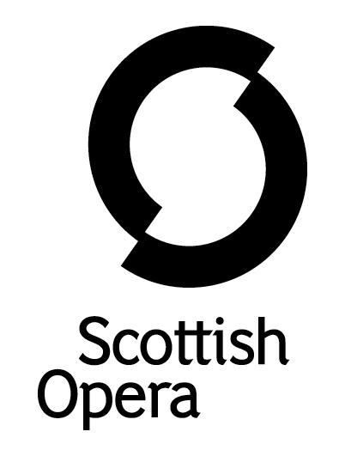

Press Release

24 May 2021

SCOTTISH OPERA INTOXICATES WITH donizetti’s COMIC ELIXIR – l’elisir d’amore

On Thursday 17 June Scottish Opera premieres a new film of Donizetti’s charming opera L’elisir d’amore (The Elixir of Love) in the latest Scottish Opera: On Screen.

Donizetti was a highly significant figure in Italian opera in the 1830s, with this comic opera being one of the most frequently performed at the time. It continues to be hugely popular today. The story is a rom-com in which the poor and naive gardener Nemorino, besotted with the beautiful and wealthy Adina, struggles to overcome the difference in social class to express his love for her. When the eccentric travelling performer Dulcamara arrives in town, deceiving locals with his lure and wit, Nemorino falls for his charm, convinced he can win Adina’s heart with Dulcamara’s magic ‘elixir of love’.

Filmed at Glasgow’s Theatre Royal on 22 May 2021, it will be available to watch on the Scottish Opera website from Thursday 17 June at 7pm in collaboration with Perth Festival. Before then, BBC Radio Scotland features audio excerpts from the performance as part of a special Classics Unwrapped, presented by Jamie MacDougall, on Sunday 13 June.

Director Roxana Haines (Così fan tutte 2020, La bohème 2020) creates a setting in the Austen era, twenty years before the opera was written, decorating the Theatre Royal Glasgow as lavish estate grounds, ideal for the collision of the worlds of high regency England and working class.

Packed full of humour and uplifting melodies, Roxana’s re-telling is the perfect summer romance to transport audiences to a different era, with extravagant period inspired costumes and intricate commedia dell’arte puppetry.

Director, Roxana Haines said: ‘Setting the narrative twenty years earlier means we can relocate it to Regency England; a time when social distancing was part of social etiquette, allowing us to embrace this as the norm in the film. This era, most familiar to us through Jane Austen's novels, was laced with obsessions with social status and romance across class boundaries, all perfectly mirrored in Donizetti's comedy.’

The cast includes guest principal Roland Wood (La bohème 2020, Tosca 2019) and three of the 2020/21 Scottish Opera Emerging Artists who also appeared in the 2020 film of Così fan tutte: Catriona Hewitson as Adina, Shengzhi Ren as Nemorino and Arthur Bruce as Belcore. This is their final film together as Emerging Artists. Elena Garrido Madrona from the Royal Conservatoire of Scotland, Alexander Gibson Opera School is Giannetta.
Stuart Stratford conducts the cast along with a full-size Orchestra of Scottish Opera (physically distanced on the stage), as well as an impressive 18 strong chorus as upper class society.
Jonathan Haswell is Film Director, having previously worked on the Company’s Così fan tutte 2020 and Hansel and Gretel 2021. With the increasing demand for digital performances over the last year, Jonathan has worked with the Company to help bring opera in to the homes of thousands through the Scottish Opera: On Screen collection.

An Audio Described version of the film will also be made available. This is the latest in Scottish Opera’s Audio Described opera films, all of which have proved extremely popular with viewers.
Available to watch via Scottish Opera’s website: www.scottishopera.org.uk/shows/lelisir-damore/.
Ends.

Notes to Editors

All performers observe current physical distancing guidelines throughout the filming of this concert.

Release Date, 17 June, 7pm
Running time approx. 2 hours
Sung in Italian

Cast List

Nemorino Shengzhi Ren*
Despina Catriona Hewitson*
Belcore Arthur Bruce**
Dulcamara Roland Wood
Giannetta Elena Garrido Madrona***

*Scottish Opera Emerging Artist
** Robertson Trust Emerging Artist
*** Royal Conservatoire of Scotland

Emerging Artists are sponsored by The Robertson Trust, Elizabeth Salvesen and Scottish Opera’s Emerging Artists Benefactors.

The Company’s Opera on Screen productions are available to watch at www.scottishopera.org.uk/what-s-on/opera-on-screen/.
The collection includes Humperdinck’s Hansel and Gretel, Mozart’s Così fan tutte, Opera Highlights, Janáček’s The Diary of One Who Disappeared, Menotti’s The Telephone and Samuel Bordoli and Jenni Fagan’s The Narcissistic Fish.

Scottish Opera is Scotland’s national opera company and the largest performing arts organisation in Scotland.
The Company's performance repertoire ranges across five centuries, from the earliest operas to newly-commissioned world premieres, working in collaboration with the world's finest singers and creatives, alongside The Orchestra of Scottish Opera and choruses. Recent accolades include a South Bank Sky Arts Award, a Scottish Award for New Music, Sunday Herald Culture Awards and a Herald Angel, as well as a 2020 RPS Award nomination.
Scottish Opera's work caters for audiences of all ages – ranging from babies to people living with dementia – and our Young Company and Emerging Artist programme support the talent of the future.
The Company tours extensively across Scotland, from the largest-scale theatres to rural venues with a capacity as low as 22, to ensure we are within reach of as many of our country's very dispersed population as possible. A miniature mobile opera house – literally, opera performed inside a converted 40-foot-long trailer on the back of a lorry – brings ‘Pop-up Opera’ performances to thousands of people each year in a range of inspiring and unexpected community locations. This represents the most extensive touring programme of any opera company in Europe and is a much-valued contribution to Scotland’s cultural and artistic life, particularly in remote and island communities.
The Company’s Education and Outreach programme, which celebrates 50 years in 2021, includes an annual Primary Schools Tour, bringing upper primary-aged children the opportunity to perform their own specially-commissioned piece, alongside three professional singers. Around 120 schools and 9,000 pupils take part each year.
Scottish Opera aims to be inclusive and affordable through availability of free and cheap tickets, as well as access performances including audio description, and performances which cater to those living with Dementia.
In the year to 31 March 2020, 116,960 people experienced Scottish Opera as audience members or as participants, across all of Scotland’s 32 Local Authority areas:
• 56 mainstage opera performances in Scotland plus tours to Belfast, London and Australia
• 8% of ticket buyers for mainstage opera performances in Scotland aged under 26
• 2,422 people watched specially-created opera productions for babies or toddlers
• 40,177 people participated in school’s workshops and performances
• 1,123 people living with Dementia participated in projects.

Scottish Opera is core funded by The Scottish Government

For additional press details please contact:
Julie McLaughlin, Press Officer, 0141 242 0552, julie.mclaughlin@scottishopera.org.uk

