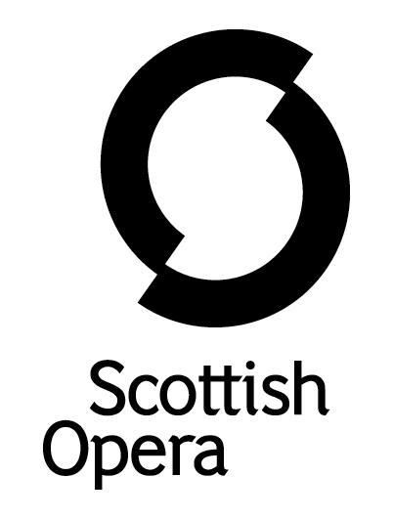

Press Release

10 August 2020

SCOTTISH OPERA’S OFFICES ILLUMINATED AS PART OF THE #LIGHTITINRED CAMPAIGN

At 9pm on 11 August, Scottish Opera’s administrative offices at Elmbank Crescent in Glasgow will be illuminated red, as part of the campaign #LightItInRed.

Members of the Scottish Opera Electrics department have arranged the lighting of the building. Almost 200 Companies from all across the events industry, as well as locations such as concert halls and convention centres will take part in the campaign, to draw attention to the serious situation facing the arts and events industry caused by the COVID-19 crisis.

It was originally Inspired by Germany's #NightOfLight2020 in July, when Clearsound Productions teamed up with Backstage Theatre Jobs to form the campaign #LightItInRed.

Andrew Storer, Technical Director at Scottish Opera said: ‘Along with theatres and concert halls nationwide, Scottish Opera’s venues and workshops have been closed since the beginning of lockdown in March. The majority of our technical staff and venue staff have been furloughed for 20 weeks with no idea as to when mainstage performances can recommence. The colour red is traditionally associated with theatre curtains and the light used at the entrance to the stage to indicate a performance is in progress. This campaign is a call to everyone working in the performing arts to keep their spirits up until we can all turn the lights back on and return to the excitement of making live music and theatre again.’

For more information visit www.lightitinred.co.uk/lightitinred

Notes to Editors

Scottish Opera is Scotland’s national opera company and the largest performing arts organisation in Scotland. It was founded by Alexander Gibson in 1962 and was inaugurated with a production of Madama Butterfly at the King’s Theatre in Glasgow. In 1974 Scottish Opera purchased the Theatre Royal Glasgow, which reopened in 1975 as Scotland’s first national opera house. The Orchestra of Scottish Opera was founded in 1980.

Notable achievements include the world premiere of James MacMillan’s Inés de Castro at the 1996 Edinburgh International Festival; complete Ring cycles at the 2003 Edinburgh International Festival, which won the 2004 South Bank Show Award for Best Opera Production; and the Achievement in Opera Award at the 2017 UK Theatre Awards for Sir David McVicar’s production of Debussy’s Pelléas and Mélisande; and a Herald Angel for the European premiere of Missy Mazzoli's Breaking the Waves at the 2019 Edinburgh International Festival.

Commissions include Five:15 Operas Made in Scotland (2008–10), The Lady from the Sea, Clemency, the double bill of In the Locked Room and Ghost Patrol (premiered at the 2012 Edinburgh International Festival), 2016’s The Devil Inside, with which Scottish Opera made its North American debut in Toronto, and 2019’s Anthropocene. Ghost Patrol won a South Bank Sky Arts Award, and In the Locked Room and Ghost Patrol were nominated for an Olivier Award. In 2018, the company made its US debut with BambinO at the Metropolitan Opera in New York, and returned to the city’s Brooklyn Academy of Music with Mark-Anthony Turnage’s Greek later that year.

Scottish Opera is committed to bringing the widest possible range of opera, performed to the highest possible standards, to the maximum audience throughout Scotland and the UK. Each year it performs in Glasgow, Edinburgh, Aberdeen and Inverness and dozens of other theatres, village halls and community centres. It also operates an extensive programme of outreach and education work which involves over 9,000 primary school children every year, as well as many other activities including adult learning and Unwrapped taster sessions. Scottish Opera receives core funding from the Scottish Government, as well as income from box office, and private and commercial support.

For additional press details please contact:
Emily Henderson, Press Manager, 07739 077551, emily.henderson@scottishopera.org.uk
Julie McLaughlin, Press Officer, 07825981241, julie.mclaughlin@scottishopera.org.uk

