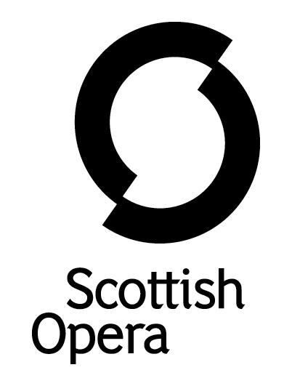

Press Release

10 July 2020

SCOTTISH OPERA PRESENTS ITS EMERGING ARTISTS RECITAL LIVE ON YOUTUBE

Scottish Opera presents a live online recital showcasing the talented group of Emerging Artists from the 2019/20 Season on Thursday July 23 at 6pm on YouTube.

This Season marked the 10-year anniversary since the programme began in 2009 and will conclude with singers Charlie Drummond, Arthur Bruce, Mark Nathan, and Associate Artist Heather Ireson performing a recital live on YouTube, which will be available for all to watch.

Presented by Director, Roxana Haines and accompanied by Scottish Opera’s Head of Music Derek Clark, the four young singers will entertain with a short, light hearted programme of operatic highlights.

The Emerging Artists programme offers young artists a period of full-time work with the Company to help them launch their careers. Initially set up to nurture outstanding young singers, the programme now also includes positions for a repetiteur, costume trainee, a composer in residence, and, during Season19/20 for the first time, an Associate Producer.
Previous Emerging Artists include soprano Jennifer France, tenor Elgan Llŷr Thomas, baritone Ben McAteer, repetiteur Jonathon Swinard, and composers Gareth Williams and Lliam Paterson.
The recital will be available to watch on our website here: https://www.scottishopera.org.uk/shows/emerging-artist-recital/
-ENDS-
www.scottishopera.org.uk

Notes to Editors

- This year’s Emerging Artists also included composer in residence Samuel Bordoli, costume trainee Jasmine Clark, repetiteur Michael Papadopoulos and associate producer Lucy Walters

- Whilst the season was unfortunately cut short, the Emerging Artists have worked on a variety of projects during their year with the Company and have continued to entertain Scottish Opera audiences during lockdown, with the Opera Highlights@Home series. Performing a range of top opera to suit every taste, from Mascagni's gorgeous Cavalleria rusticana to Mozart's Don Giovanni.

- Samuel Bordoli ARAM returned for a third year as composer in residence and this season composed Scottish Opera’s first digital opera, The Narcissistic Fish, which was launched in June. This digital work saw Samuel create an original score for the opera short, starring fellow emerging artists Arthur Bruce, Charlie Drummond and Mark Nathan.

- This year Samuel has continued to grow on his already impressive body of works with the Company, composing a new piece for Opera Highlights and a prelude to A Midsummer Night's Dream entitled Hermia’s Nightmare.

- Scottish baritone Arthur Bruce was The Robertson Trust Scottish Opera Emerging Artist 2019/20. This season at Scottish Opera, Arthur performed in a new production, Amadeus & The Bard: 18th Century Cosmic Brothers, about the links between Wolfgang Amadeus Mozart and Robert Burns. He also joined the Spring Opera Highlights tour, which was widely praised and was due to perform in Utopia, Limited and The Gondoliers.

- Soprano Charlie Drummond joined the Company’s Opera Highlights Autumn tour and was also due to perform in A Midsummer Night’s Dream, The Gondoliers and Utopia, Limited.

- Baritone Mark Nathan also joined the Opera Highlights Autumn tour and was due to perform in A Midsummer Night’s Dream and The Gondoliers.

- Elizabeth Salvesen Costume Trainee Jasmine Clark worked on Scottish Opera’s 2019/20 Season productions in the Costume Department, to produce intricate costumes for the stage.

- London-born repetiteur and conductor Michael Papadopoulos was the 2019/20 Emerging Artist repetiteur. This Season at Scottish Opera, Michael worked on Susanna’s Secret, Tosca and Nixon in China, and as Music Director/Pianist on the Opera Highlights Spring tour. He was also due to work on The Gondoliers and Utopia, Limited.

- Lucy Walters was the Emerging Artist associate producer. Jointly appointed by Opera Ventures and Scottish Opera, this year Lucy primarily worked on the future life of the Company’s co-production of Breaking the Waves.

- Scottish Mezzo-Soprano, Heather Ireson was this year’s Associate Artist and performed in Nixon in China and Iris and was also due to perform in The Gondoliers and Utopia, Limited.

- The Emerging Artists are supported by The Robertson Trust, Elizabeth Salvesen, Idlewild Trust and Scottish Opera’s Emerging Artist Benefactors.

Scottish Opera is Scotland’s national opera company and the largest performing arts organisation in Scotland. It was founded by Alexander Gibson in 1962 and was inaugurated with a production of Madama Butterfly at the King’s Theatre in Glasgow. In 1974 Scottish Opera purchased the Theatre Royal Glasgow, which reopened in 1975 as Scotland’s first national opera house. The Orchestra of Scottish Opera was founded in 1980.

Notable achievements include the world premiere of James MacMillan’s Inés de Castro at the 1996 Edinburgh International Festival; complete Ring cycles at the 2003 Edinburgh International Festival, which won the 2004 South Bank Show Award for Best Opera Production; and the Achievement in Opera Award at the 2017 UK Theatre Awards for Sir David McVicar’s production of Debussy’s Pelléas and Mélisande; and a Herald Angel for the European premiere of Missy Mazzoli's Breaking the Waves at the 2019 Edinburgh International Festival.

Commissions include Five:15 Operas Made in Scotland (2008–10), The Lady from the Sea, Clemency, the double bill of In the Locked Room and Ghost Patrol (premiered at the 2012 Edinburgh International Festival), 2016’s The Devil Inside, with which Scottish Opera made its North American debut in Toronto, and 2019’s Anthropocene. Ghost Patrol won a South Bank Sky Arts Award, and In the Locked Room and Ghost Patrol were nominated for an Olivier Award. Last year the company made its US debut with BambinO at the Metropolitan Opera in New York, and returned to the city’s Brooklyn Academy of Music with Mark-Anthony Turnage’s Greek in December.

Scottish Opera is committed to bringing the widest possible range of opera, performed to the highest possible standards, to the maximum audience throughout Scotland and the UK. Each year it performs in Glasgow, Edinburgh, Aberdeen and Inverness and dozens of other theatres, village halls and community centres. It also operates an extensive programme of outreach and education work which involves over 9,000 primary school children every year, as well as many other activities including adult learning and Unwrapped taster sessions. Scottish Opera receives core funding from the Scottish Government, as well as income from box office, and private and commercial support.

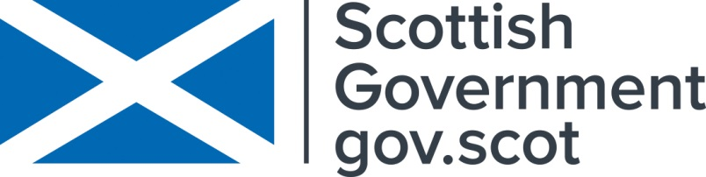

For additional press details please contact:
Julie McLaughlin, Press Officer, 0141 242 0552, julie.mclaughlin@scottishopera.org.uk

